Anytime, Anywhere

FURNITURE & EQUIPMENT

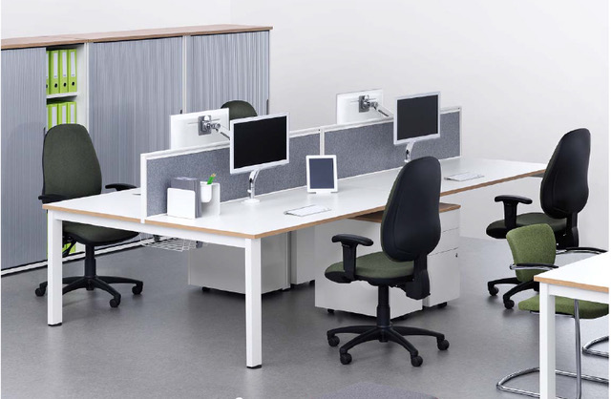

SECTION 1 - WHAT YOU NEED TO KNOW BEFORE YOU BUY!

In line with the Office and HQ Transformation Project, we aim to review and refurbish Council buildings. To ensure consistency, we should procure the same style of furniture within an agreed colour palette for all new buildings, refurbishments and replacement items. There is a standard specification for all office furniture and kitchen furniture, should that be required. This will enable increased capacity across council buildings and provides us with a corporate brand and ensures consistency across the Council offices. This also means that if we need to move furniture from one building to another, we will still have a consistent style and brand. This will help staff to feel equal and valued and ensures efficient and best use of rooms. Following the process will also ensure value for money from a procurement perspective.

GENERAL POINTS TO CONSIDER:
If the options to reuse or refurbish furniture are not practical and you need to procure new furniture there are a number of considerations that will need to be made, especially for new offices or refurbishments where the estimated value is above £50,000. These include the following:

- Planning is crucial as procurement exercises can take between 4-6 months to complete
- Think about your space and what you need
- Consider the floor plan and pay particular attention to electrical and telephone points. Changes will require additional time to complete and will incur an additional cost
- Try and avoid a call centre look and use different combinations of banks of desks and different layouts and break out furniture
- Most offices will need break out spaces, which helps create the perception of space and breaks up the room. This also provides space for colleagues to discuss issues where this is necessary away from desks rather than using meeting rooms.
- Ensure that you are providing sufficient space between desks for people to move around to meet health and safety requirements
- The type of furniture you choose will depend on the space available. Depending on the office it might be able to be used for lunch, tea breaks, meetings, 121 conversations so it should feel multipurpose. Where possible, involve the team in what is needed and ordered. Try and use different Council of the Future colours to break up the room and create the feel of different spaces. Use the Council of the future colours or black, white and grey.
- There should be limited desk dividers – this leads to a more open office and more collaborative working although does help with privacy and noise levels where this is important.
- “phone booths’ can be useful for personal and confidential calls
- Be prescriptive on what choices teams have in terms of furniture and colours – this must follow the specification as set out in this document
- Try and use different Council of the Future colours (or black, white and grey) to break up the room and create the feel of different spaces.
- Flooring. If flooring is being replaced as part of the refurbishment then the best option is a vinyl wood effect. The vinyl should be flat, non-slip with no grain or indents. Some teams have however found this carries noise and initially, until teams become used to the new flooring, caution may be required when using desk chairs with wheels on this surface.
- Offices should be provided with reasonable equipment food and drink prep areas, e.g. kettle, microwave. Personal electrical items including should not be used in any circumstances. Toasters should not be purchased/used.
- Grey or black desk mats can be purchased to reduce glare should this be an issue.

OUR FURNITURE

Chairs
The design of the chair in the specification provides postural support and recommended to support individuals with back problems. Given the different size and height of employees, chairs are available in both regular and small seat sizes. An inflatable lumber support, fold down arms and slide seat are all part of the specification. Given the design and attachments, the chair will be suitable for all employees including those with back problems. Where the standard specification is not suitable (expected to be extremely minimal situations) advice needs to be sought from the Health, safety and wellbeing team and Occupational Health before any purchase is made. Occupational health are fully familiar with the specification and are happy that this will be suitable for the majority of employees requiring additional postural support.

It is recommended that a small number of chairs are ordered in a smaller size, although it is recommended that a trial small sized chair is requested from the supplier before ordering. For ease of identification of the larger/smaller chairs, the chairs can be purchased in the different colours.

Stand Up Desks
Sit/Stand desks allow employees to change their posture between sitting and standing whilst continuing to work. This means workers are better able to manage injuries and medical conditions without affecting their work performance. This is only suitable for mobile/flexible/remote workers who have a laptop or other suitable device. Sit/stand desks can help:

- Improve productivity
- Reduce the amount of time they sit
- Increase motivation and concentration
- Reduce fatigue levels
Sit/Stand desks should be provided in all mobile and flexible workspaces. The sit/stand desks should have a minimum height adjustability between 660mm and 1200mm with an electric mechanism to adjust the height. A minimum of 2 sit/stand desks should be provided in all flexible & mobile workspaces up to 20 desks. In larger workspaces additional sit/stand desks should be provided in a 1:20 ratio.

Number of Desks | Sit/Stand desks to be provided
Up to 20 | 2
21 – 40 | 3
41 – 60 | 4

Desks should be the same size as other desks within the specification -1200mm by 800mm length/depth. Desk should be white or light grey.

Storage
Each employee should be offered an individual locker for personal belongings. Pedestals should not be used. Lockers should be located either within the office employees are based or within the close proximity of their office and should be on the same floor as the working area. In addition, when space planning and designing the office, each workstation will be provided with c2 linear metres of storage, however this could be lower if you are moving to a paperless office arrangement. For larger storage units, you might want to think about storage units with slopping tops - this avoids clutter. If possible, use small cupboards for things like the confidential waste bins, the paper at the side of photocopiers, etc – helps with clean office policy. In space planning, lockers should always be stacked x 4 high to facilitate more floor space. If you are tight on space and want to include a stand up desk, then consider the stand-up desk that has the lockers fitted at the end of the desk. This can save some space.

Monitors
Desks should be set up with the new modern technology specification. In most cases, all desks will be set up with 2 monitors. There may however be some touchdown spaces that don’t need a monitor. You should purchase a double arm monitor for each desk.

Power Supply
Charging/power supply will be available on desks as part of the desk specification, but additional capacity for mobile/flexible workers to charge phones and laptops may be required. USB charging points should be provided or available on PC’s. The design should avoid trailing cables and cables should be able to be stored in cable trays. Desk suppliers will be able to provide this. Again cable trays are referred to in the desk specification. Desks should therefore include cable management.

Telephones
Telephone lines will be required, although you may not require a telephone for each desk as many employees will have mobile phones. Any proposed changes need to be notified to ICT as soon as possible in advance of the changes. The project plan in Part 1 of the Guidance pack identifies the need to assess needs and involve ICT as early as possible.

TV’s/Conferencing Facilities
A suitable TV should be available within each building for video conferencing. There should be one in each building as a minimum. Where this is being utilised to capacity or where budget is available, additional TV’s should be purchased for meeting rooms. When considering these facilities, remember that power and data points will be required. The Presentation and Audio Visual Equipment framework on Scotland Excel provides access to this equipment.

It is very important when investing considerable amounts of time and money in new technology that you ensure best value for money, both at the point of purchase and over the life cycle of the products. Therefore, you should consider the cost to buy and run the chosen solution over the estimated life of the solution. This includes equipment costs, installation costs, electricity consumption, manufacturer warranty cover provided at point of purchase etc.

If replacing an existing solution/component, a more modern, up to date replacement should be considered. The room environment should also be taken into account and these circumstances may need to be discussed with the ICT team. The size of group the room in question usually accommodates will have a bearing on the size of equipment required.

You should contact the ICT team in the first instance to discuss products and solutions the Council endorse for your premises. This should cover hardware and software. In many instances, included software is only licensed for use on related hardware products and not for use on any 3rd party products or solutions.

Licenses
You may require to consider the purchase of additional licenses for some software eg where you require new logins or email to be set up for employees who didn’t previously have an MS licence. You should discuss this with IT when considering equipment.

Old Furniture
Once you have a date for delivery of the new furniture, you need to consider disposal of the old furniture. An agreed process has been developed for this. Click here to view.

OUR COLOUR PALETTE

All rooms are different. Managers can contact the Design Team within the Communications & Participation Unit of Corporate & Housing Services for information on accent colour matching and additional design features.

Core Colours
Walls: There should be a mix of white and grey walls. Some rooms might have more light and can take more grey or depending on the surface, grey might be considered better. In some rooms, with limited light, white might be considered better. All rooms should have a mix of grey/white. Where possible the employee group should be asked their preference for the split: i.e. 3 white and 1 grey wall, or 3 grey and 1 white. There is no right or wrong combination and it is up to each team to agree what suits them best.

- white walls. Matt white emulsion.
- The grey walls, shade is Dove Grey – Leyland paint. Some contractors may use alternative paint manufacturers and if this is the case and alternative close match should be used. The swatch below is Dove Grey for ease of reference. The website showing the colour chart, including Dove Grey can be found here. http://www.leylandtrade.com/colour/leyland-colours-bs4800

Accent Colours:
The four Council of the Future accent colours are magenta, blue, lime and orange and these can be used to add colour.
￼

The Council of the Future logo or wording can be used on one of the walls to break up the colour.

Doors, Windows, Skirting Boards:
Doors, windows and skirting boards are normally white gloss.

Seating:
Chairs are black / grey in colour and accent colours should only be used for the back of the seat back. The team can pick the colours from the council of the future colour palette. Some colour is important to brighten up the room.

SECTION 2 – THE STANDARD SPECIFICATION

There is a standard specification for all office furniture and kitchen furniture, that must be used when such equipment is required. This enables increased capacity and provides us with a corporate brand, ensuring consistency across the Council offices in the short and long term. This will help employees to feel equal and valued and ensures efficient and best use of rooms as well as fairness to all employees.

- Our Workstations

 | DEFINITION | SPECIFICATION | COLOUR | SUPPLIER
CHAIRS | Task chairs for workstations with rollers. | Chairs will:  - be easily adjusted from the seated position  - seat base that tilts and is height adjustable  - have a seat slide  - back rest that tilts and is height adjustable  - five star castor base  - backrest should be hard and not mesh to provide sufficient support  - Waterproof and stain resistant  - Wipeable fabric  - Different size of chairs to suit individuals of different height and weight.  - A small number of smaller seat pad chairs can be purchased to meet the needs of the team | Seat pad and back rest should be dark grey/black. The back of the seat pad should be a colour from the council of the future colour palette. | 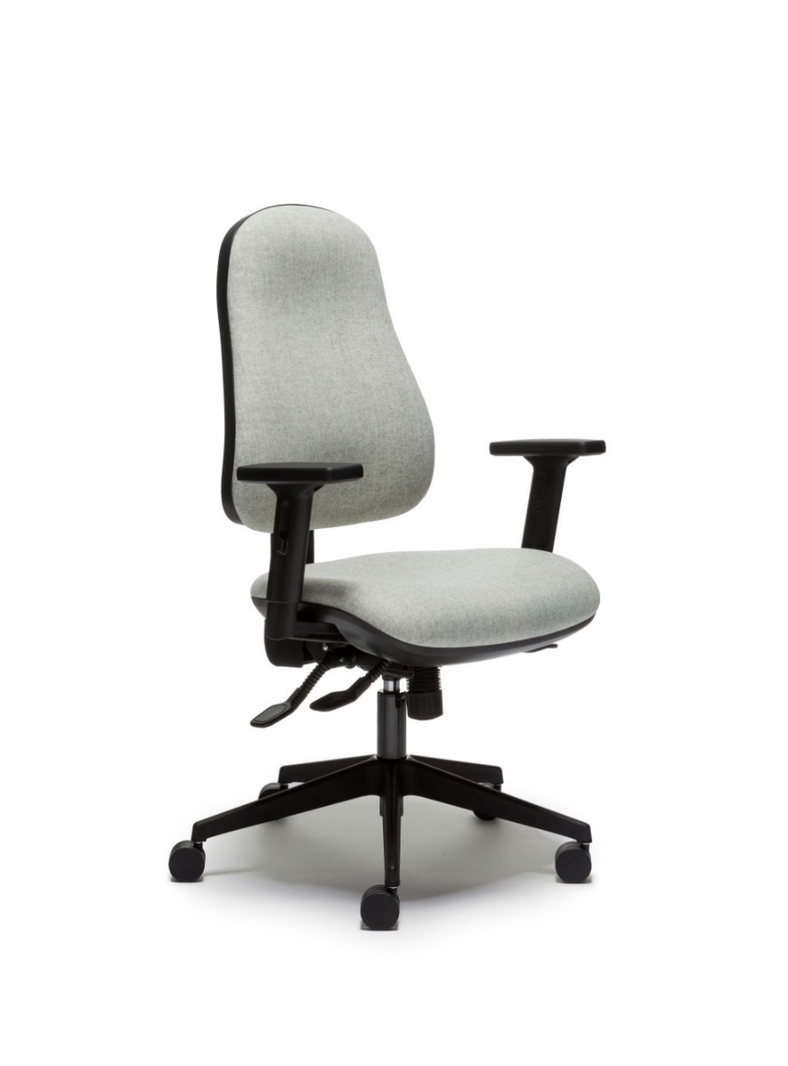
DESKS | Sit down desk | 1200mm width x 800mm depth although depending on nature of work 600m depth can be used. Depending on needs, these can be x2, x3 or x4 in length.  5% of desks will have manual adjustable heights.  Desks must have cable management included to avoid trailing cables (see below for some examples)  Desks will have power supply included in the desk for charging phones and laptops  Desk will be of mid quality and standard thickness.  Desks should be fitted with Dual Monitor Arm - Able to support up to 2 x 27" monitors off its dual bar and supports weights of between 0-9kg in total. – see note on double monitors above.  See below for pictures of items for cable management | Matt White surface or light grey in colour  Silver frame | 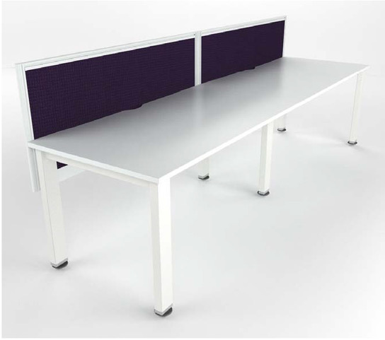  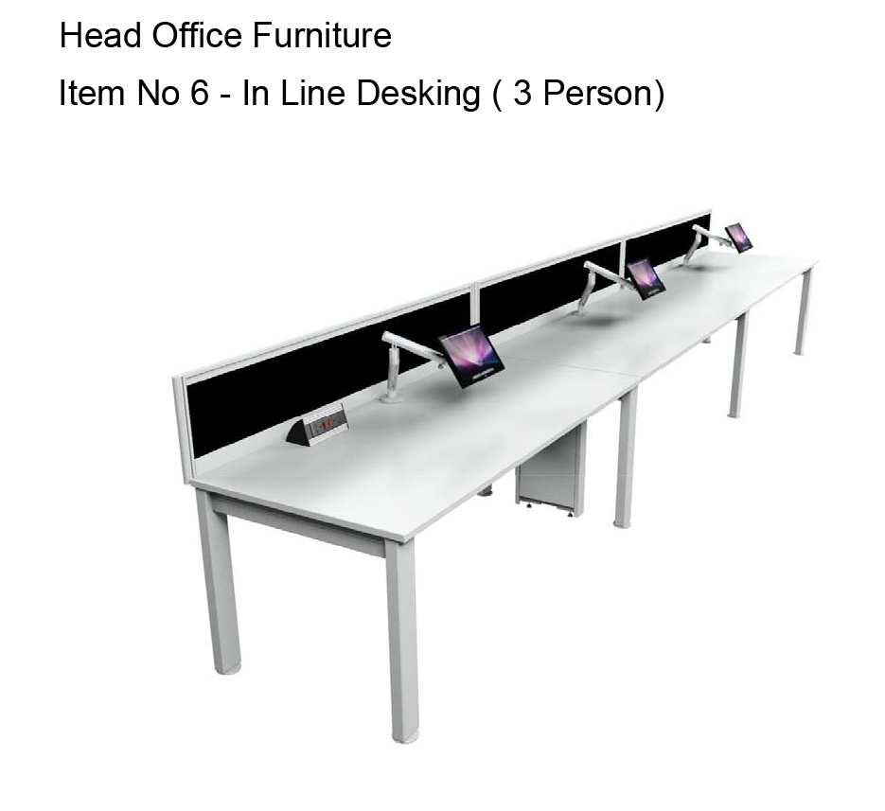
 | Stand up Desks | Stand up desks should have a minimum height adjustability between 660mm and 1200mm.  Mechanism should be electric where possible to adjust the height.  A minimum of 2 sit/stand desks should be provided in all flexible & mobile workspaces. In larger workspaces additional sit/stand desks should be provided in a 1:20 ratio.  Desk will be of mid quality and standard thickness.  1200mm width x 800mm depth although depending on nature of work 600m depth can be used.  Grey or white desk mats can be purchased to reduce glare should that be an issue/preferred. | Matt white surface or light grey  Silver frame | 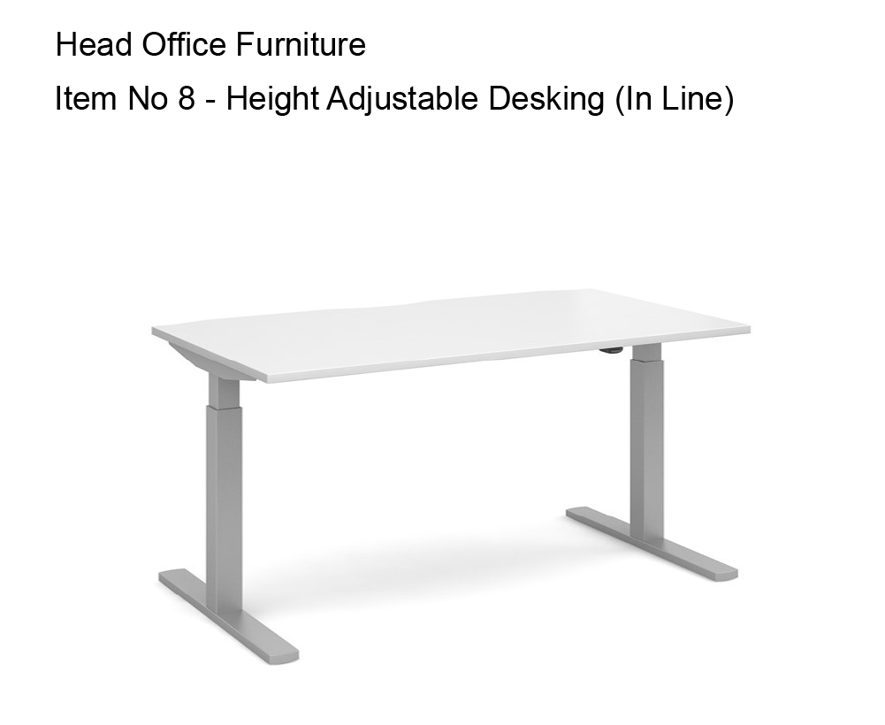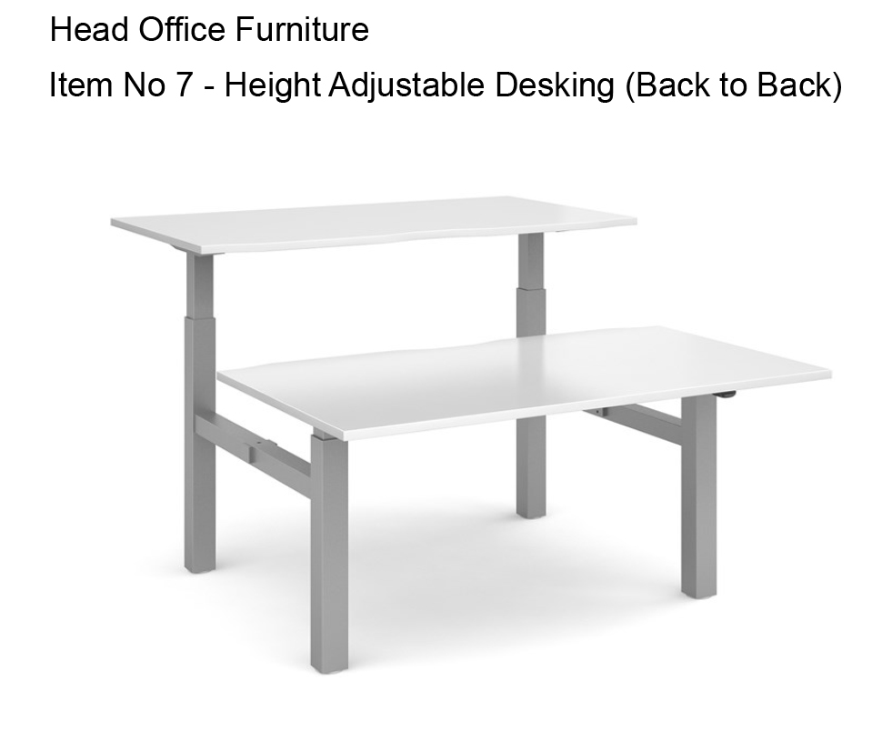
LOCKERS | 1 personal locker per employee | 1605mm high lockers  Lockers should not have post slots and optional internal shelf  Lockers should be stackable and lockable. Lockers should be stacked 4 high. This depends on space and total height. The height should allow for easy access. where possible the bottom locker can be a pull out drawer to facilitate easier access.  Lockers should have a 10 year guarantee  label holders for each locker | Carcass: grey | Bisley New System File Lodge 6 x 13.5inch doors & 2 x 13.5inch drawers SLD0847LS3BMAB  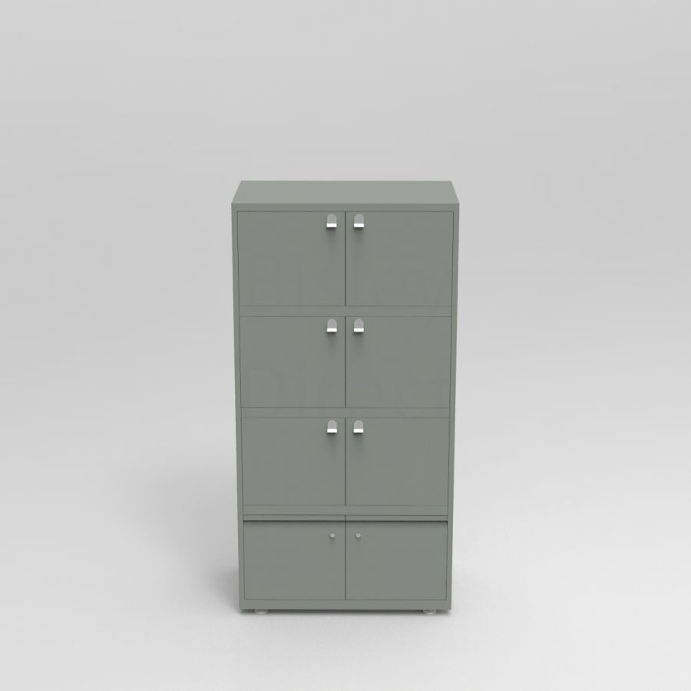
DESK DIVIDERS | One divider separates 2 desks that face on to one another.  Note: These should only be used where necessary as desk dividers can affect collaboration of teams. Teams should be asked their preference | Glazed & Etched Screens to run horizontally across the desk  Size to fit desk – 1200 x 350mm height | Polar White Glazed stripe with frame | 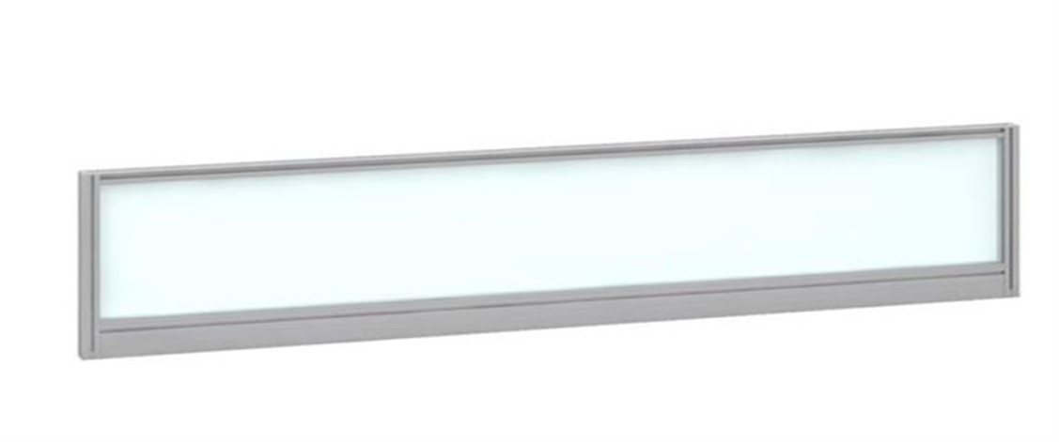

- Our break out areas
 | DEFINITION | SPECIFICATION | COLOUR
CHAIRS | Office area | Teams need to consider the space available and the needs of the team. A range of break out furniture will be provided as options (to be added)  This will include low tables and chairs, caravan style tables and chairs | Team to choose colours from council of the future colour chart | See below for examples
 | Kitchen area | Plastic  Wipeable | White or colours from colour of the future colour chart.  Note: the team should choose the colours. | See below for examples
TABLES | Office area break out | Teams need to consider the space available and the needs of the team. A range of break out furniture will be provided as options (to be added).  These could be round, square or rectangular to meet the shape of the space.  Table will be of mid quality and standard thickness. | Matt White  Silver legs | See below for examples
 | Kitchen area | Café style round tables, space for 4 people to sit (based on space in the room) | White | See below for example

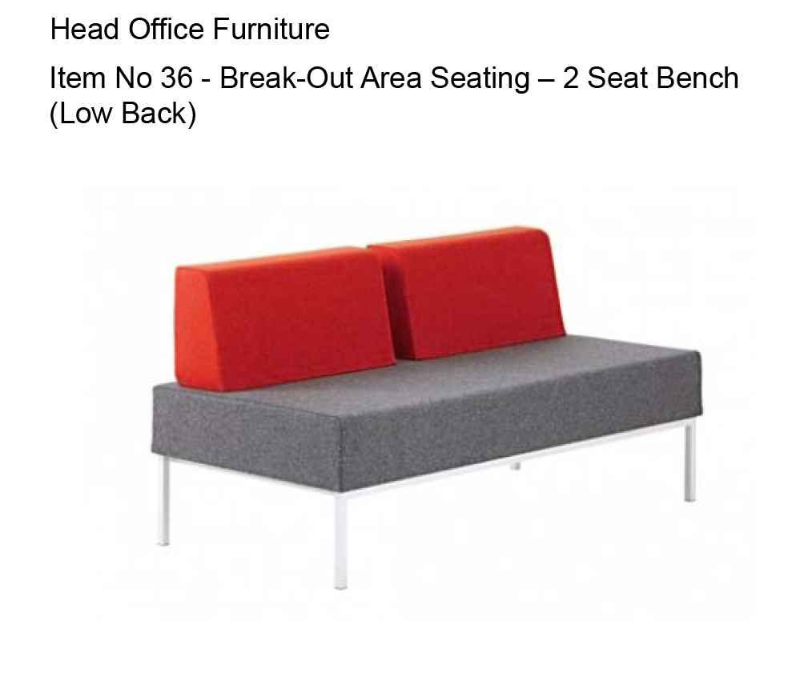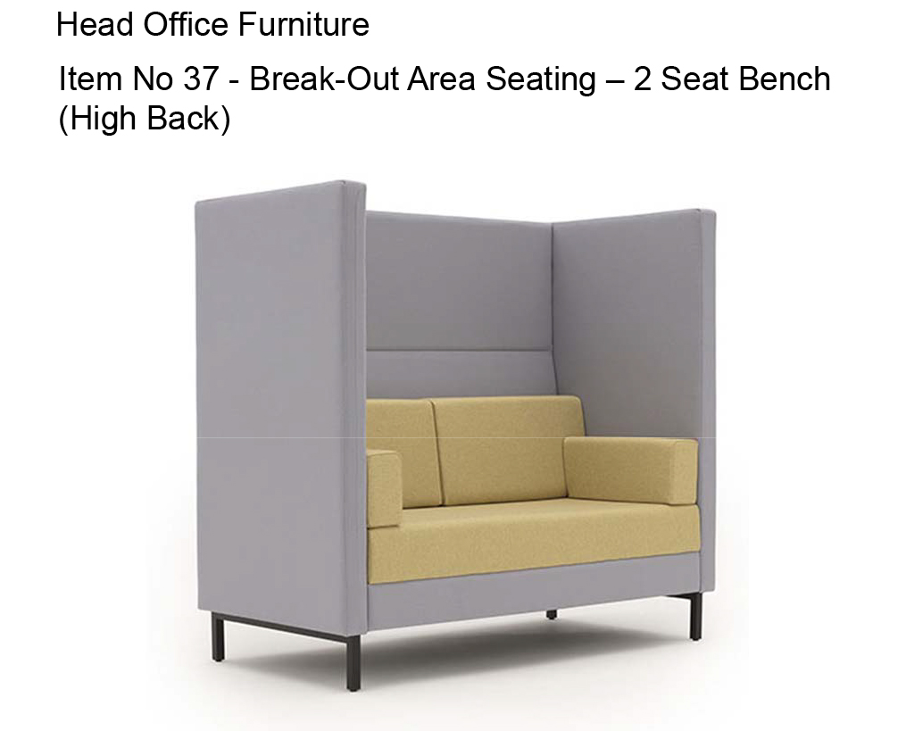
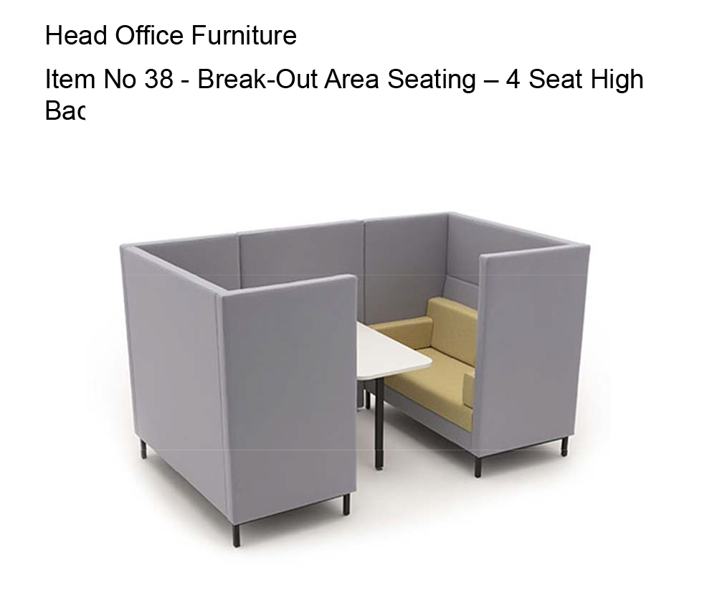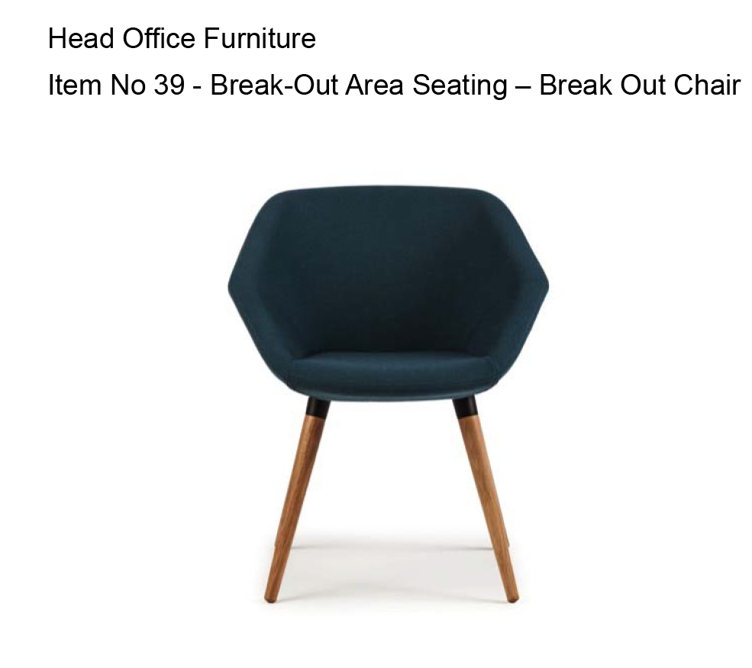
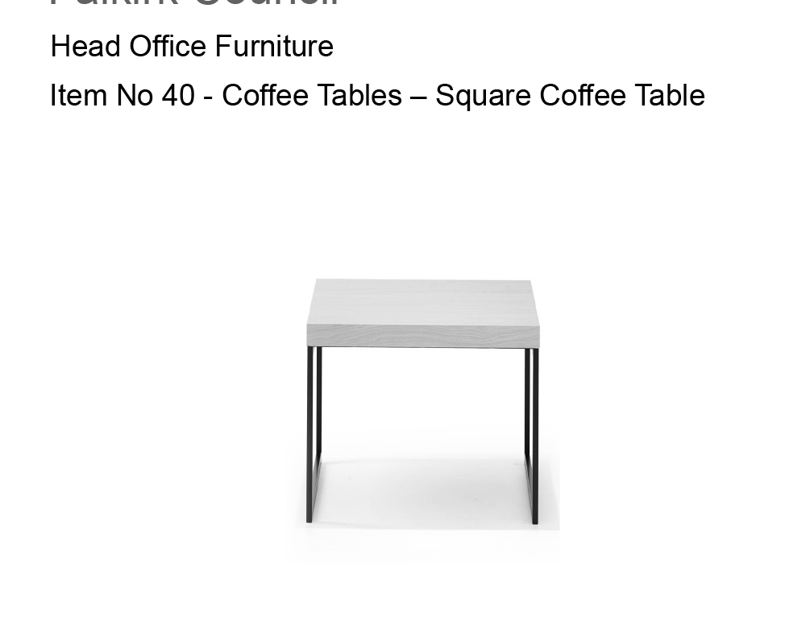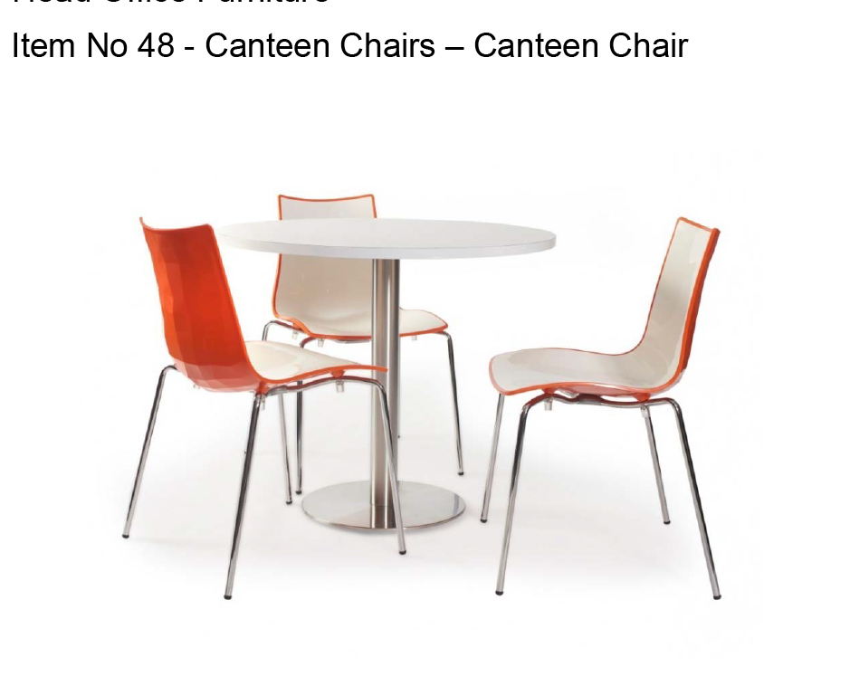

- Our meeting rooms

 | DEFINITION | SPECIFICATION | COLOUR
CHAIRS | individual chairs | This will depend on the needs of each room/office. | Team to choose colour from colour palette | See examples provided
TABLES | Table for meeting rooms | Table – can be square, circular or rectangular to meet the shape of the room.  Table will be of mid quality and standard thickness. |  | See below for examples
AUDIO/VISUAL | TV\Interactive boards | Supply, Delivery, Installation, Commissioning & Maintenance of Presentation & Audio Visual Equipment 35/10 PC/1  Purchased through SSUK Scott.Passmore@ssuk.co.uk |  | Please note: At the time of writing this specification, the contract/supplier was changing. Please therefore contact IT for further support and supplier information for specific products.
 | Industrial TV | ViewSonic 75" CDE7500 Commercial Grade 4k LED Wall mounted and input panel  https://www.viewsonic.com/us/commercial-displays/shop.html?spec_display_size=2664
 | Interactive Boards | Clevertouch pro interactive board with adjustable stand and input panel Two sizes 75”& 90”  https://www.clevertouch.com/products/compare-models#
 | TV Webcam and peripherals | • Web Cam ( Cisco SX10)  • SX 10 TV bracket  • Wireless Keyboard and mouse  • Igel device  • Cisco IP 7841 phone with collaborative licence  • 10m HDMI cable  • Display port to HDMI Convertor  • 2m Display Port to HDMI cable  • Interactive clicker  • Wireless internet connection (BT Wi-Fi)  • Email Address for the meeting room to be configured on the TV  • Two double rg45 network wall socket  • One double wall 240v power socket  • Two double skirting board 240v power socket’s  • Office 365-Cisco video bridging software |  | This will give you  • Connection through the USB dongle to the screen with a laptop (interactive board only)  • Connection through the HDMI cable and Display port to HDMI Convertor  • PowerPoint slides with the Interactive clicker  • Be able to log into Falkirk Cloud using the Igel Box  • Cisco Video conferencing with the Webcam to meeting room to meeting room and multiple screens though the BT engage system  • Office 365 Video conferencing with the Cisco Webcams independently through a mobile webcam  • Screen share though the Cisco webcams  • Screen share through Office 365 though a mobile webcam  • The ability to email the whiteboard capture (interactive board only)

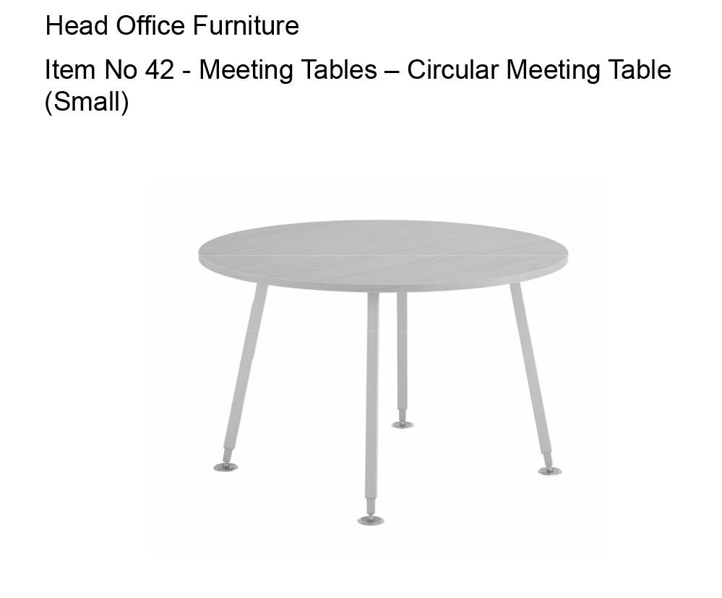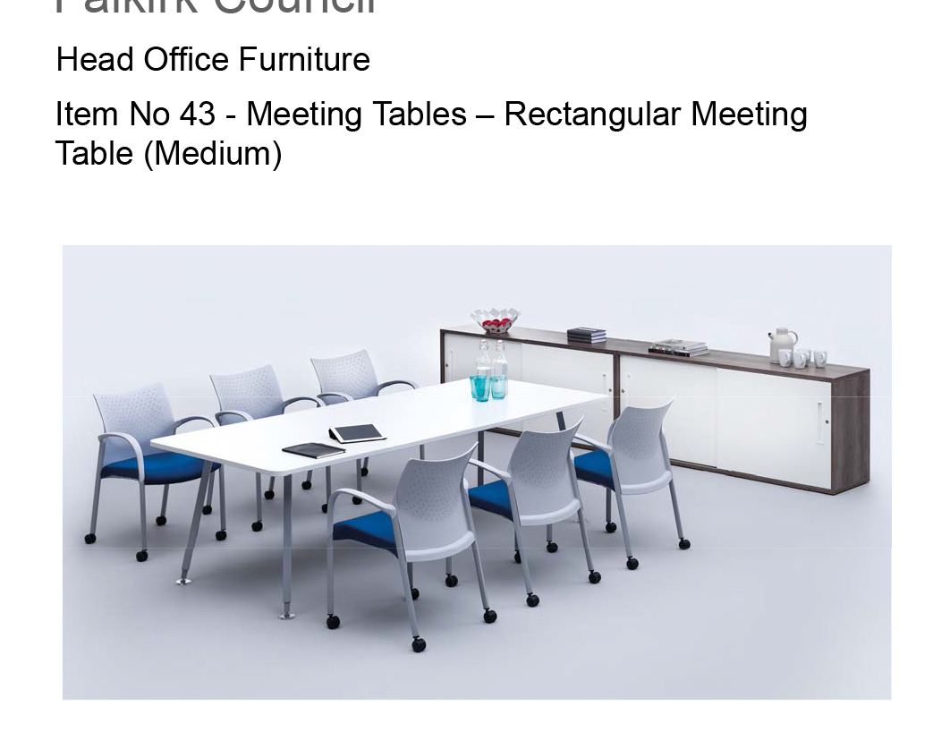

CABLE MANAGEMENT

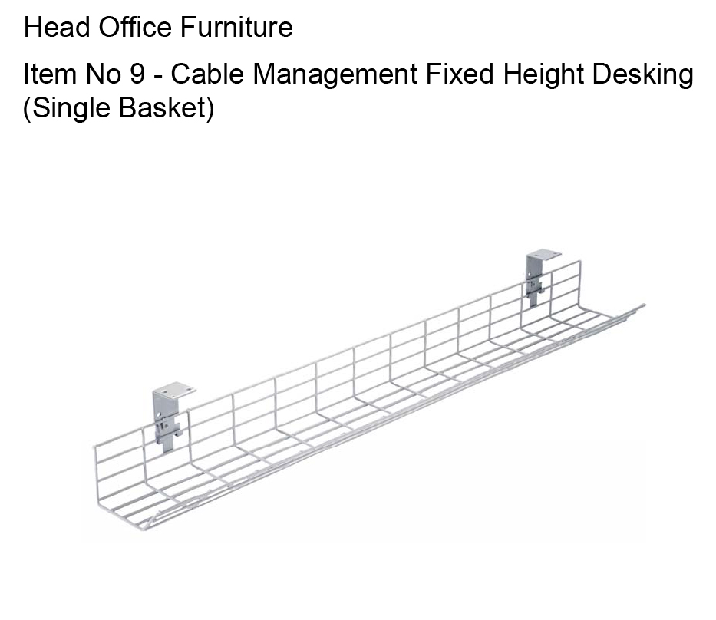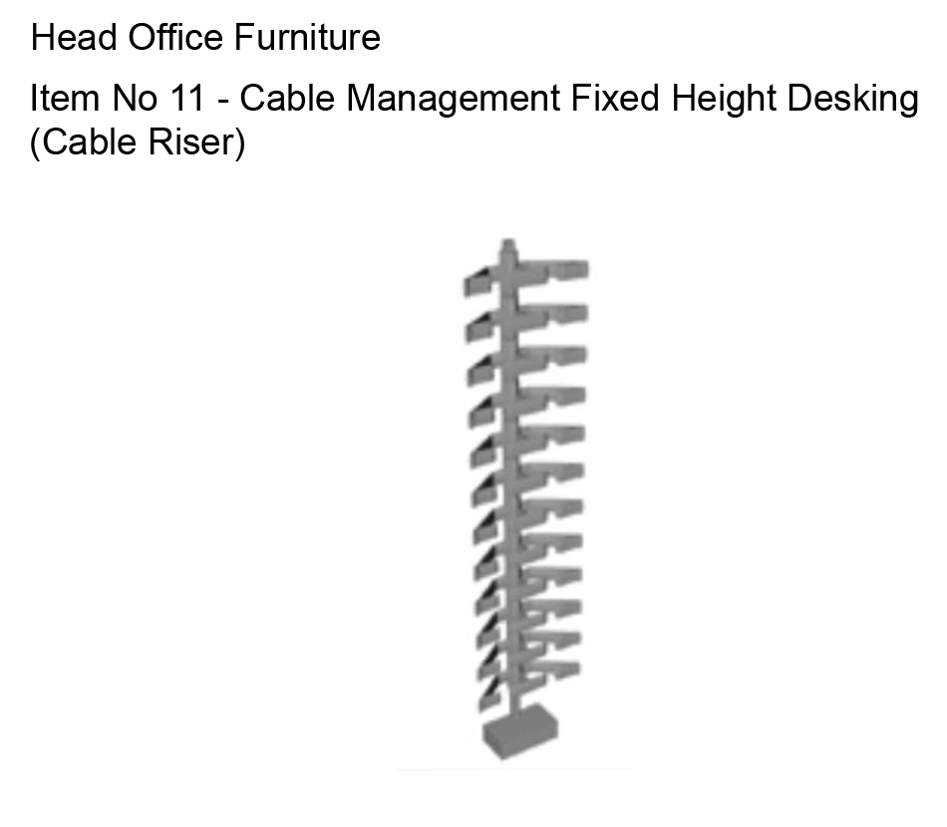
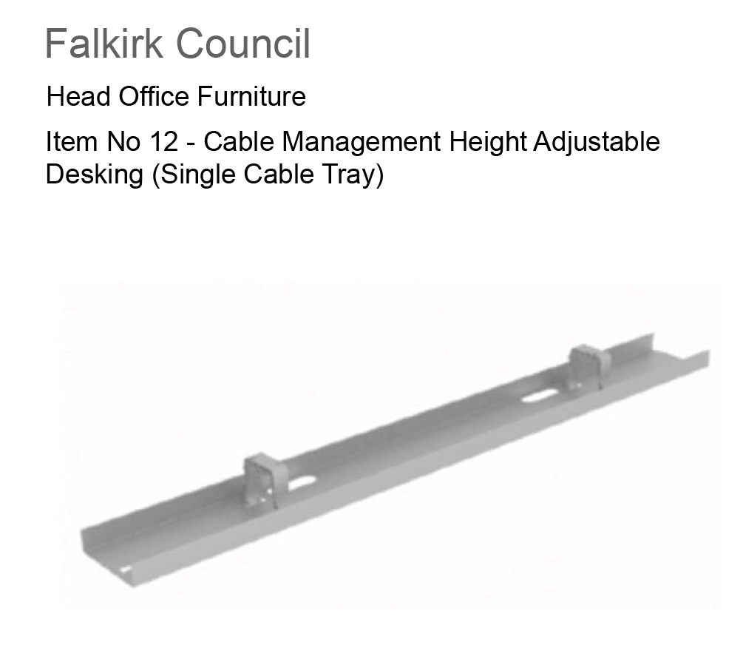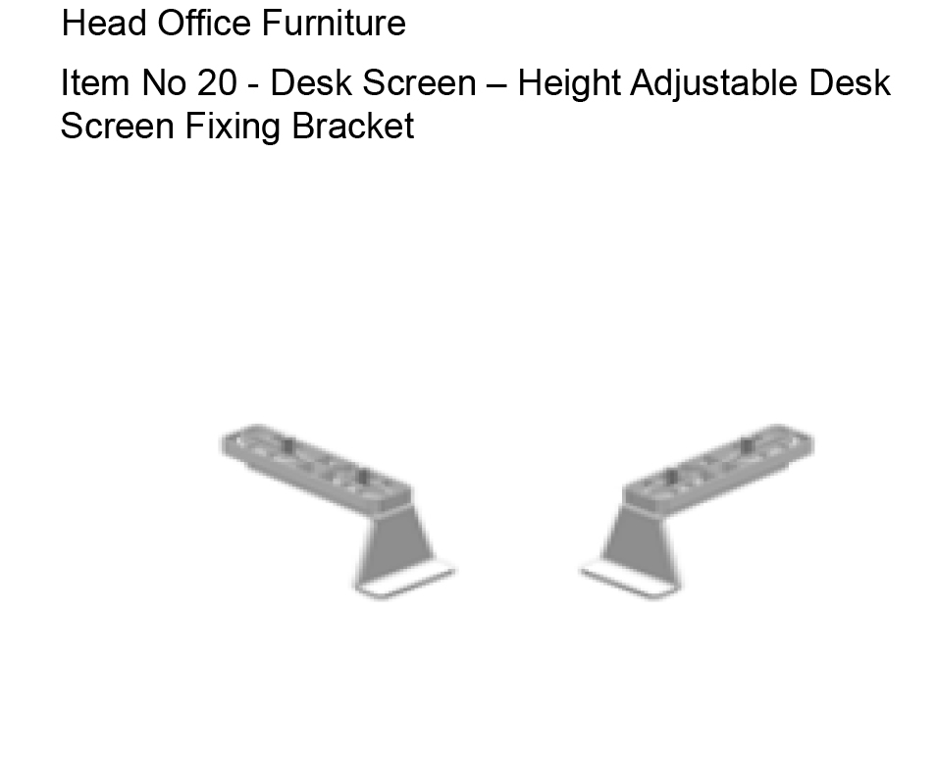

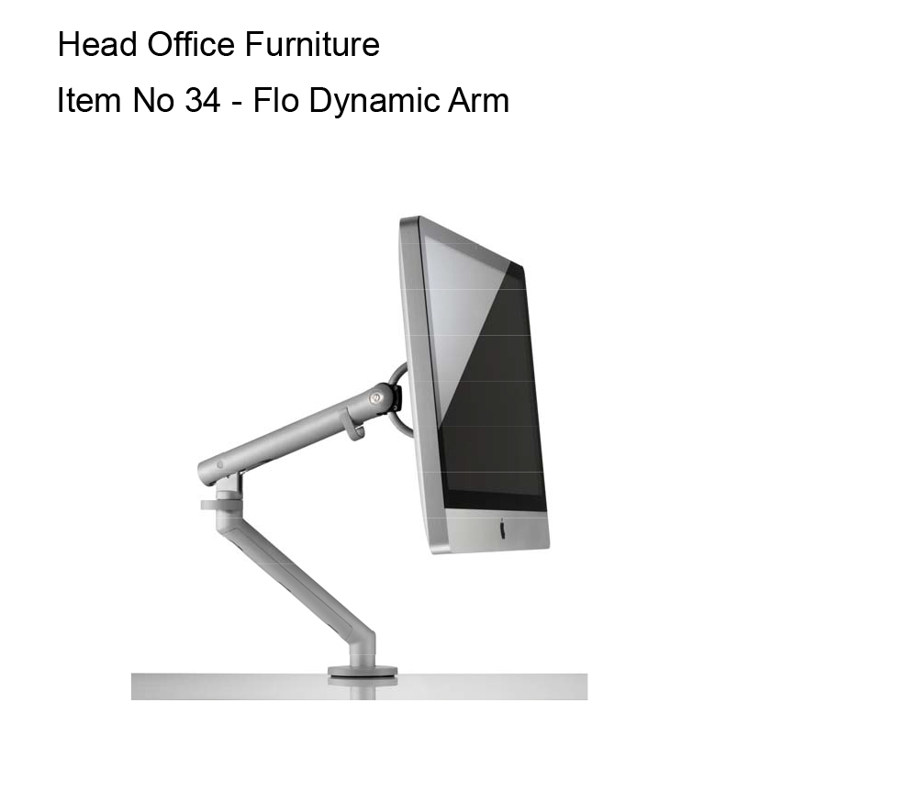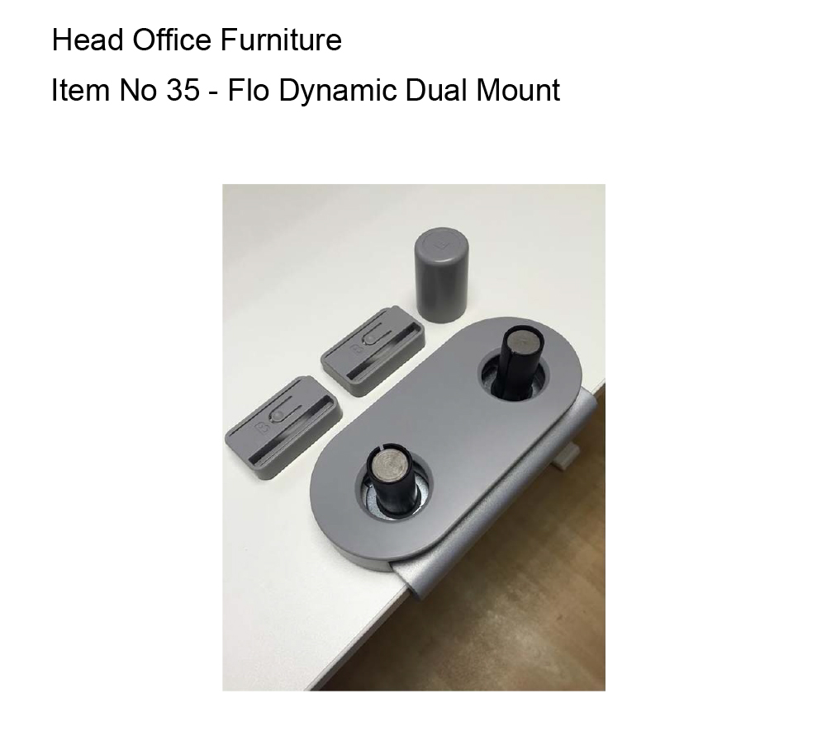

Each office will have different needs but the colour palette and branding should be the same across all buildings. An example of what has been previously used for the Foundry is below.

