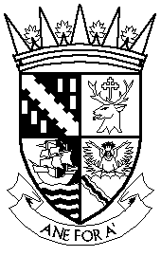  FALKIRK COUNCIL LICENSING BOARD | Licensing Unit  Falkirk Council  The Foundry  4 Central Park  Central Boulevard  Larbert, FK5 4RU  Telephone: 01324 501575  e-mail: licensing@falkirk.gov.uk  DX 556562

APPLICATION FOR CHANGES TO PERSONAL LICENCE

CHANGE OF ADDRESS

DETAILS OF APPLICANT

Personal Licence No.
Name
Telephone No. | Landline Mobile
Are you an existing Designated Premises Manager? | YES/NO *delete as appropriate  Name of Premises

DETAILS OF EXISTING ADDRESS

Current address
Postcode

DETAILS OF NEW ADDRESS

New address
Postcode
Signature of Licence Holder
Date

DO NOT WRITE IN THE SHADED AREA
Fee - £25.00

Note: the original Personal Licence must be returned with this form.
Your privacy is important to us. You can find out how we deal with your personal information here: http://www.falkirk.gov.uk/privacy/law-licensing/licensing/

For use by the Licensing Board only

Application checklist

Date received
Fee amount
Receipt number
Received by (INITIALS)

