FIRE & LIFE SYSTEMS - PREMISES PLAN SYMBOLS

Symbol | Description
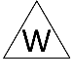 | Water main shut-off valve
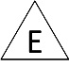 | Electrical Main Switch
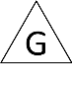 | Gas shut-off valve
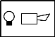 | Fire Alarm Control Panel
 | Manual Call Point
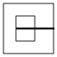 | Emergency Light
 | Exit Sign and Emergency Light combined
 | Sounder (Warning)
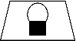 | Flashing Light (Warning
 | Smoke Detector
 | Heat Detector
 | CO₂
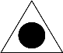 | Foam
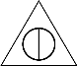 | Water
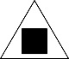 | Dry Power
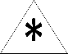 | Wet Chemical
 | Fire Blanket
 | Escape Route
 | Stair

