Food Safety Guidance

Cross Contamination Guidance

Harmful bacteria such as E. coli O157, Campylobacter and Salmonella can easily spread to ready-to-eat (RTE) foods, such as salads and cooked foods, through direct contact with raw foods or indirectly by staff, equipment, contaminated surfaces or cleaning materials.

Contaminated food can make your customers seriously ill and can even kill. This guidance, if followed correctly, will help you control the risk of cross-contamination within your business.

To avoid cross contamination you must make sure there is:-

- adequate separation between raw and RTE foods;
- effective cleaning and disinfection practices;
- good personal hygiene, particularly washing hands thoroughly and handling food hygienically; and
- effective and appropriate management controls and staff training in place.

1.0 Separation

If possible you should have separate staff, equipment, utensils and areas for preparing and storing raw and RTE foods (see diagram 1.1).

If this is not possible you must consider and put in place the following measures:

Work areas can be used for both raw and RTE foods, but only if separated by time. Surfaces must be thoroughly cleaned and disinfected before being used for RTE foods. As an additional safety measure, you must not use work surfaces directly to prepare food and instead use a suitable barrier, for example a chopping board or a container, as the food contact surface.

Staff can handle and prepare both raw and RTE foods, but they must be adequately trained and observe strict hygiene controls, for example they could reduce hand contact by using separate dedicated utensils to touch food. If handling food staff must wash their hands between handling raw and RTE foods. It is best practice to use disposable gloves and/or aprons for raw food preparation.

Storage facilities should be of suitable size so that there is sufficient separation between raw and RTE food to avoid cross-contamination. It is advisable to store raw meat below RTE foods to avoid juices dripping onto RTE food or its packaging. Using sealed containers can also reduce the risk of contamination.

Utensils including chopping boards, tongs, containers etc. should, where possible, be dedicated for either raw or RTE food and colour coded to help staff identify their use. Where this is not possible they should be put through a dishwasher between uses. Make sure that dishwashers are properly maintained, loaded correctly, run on a full cycle and not interrupted once started.

Sinks: sinks may be used for washing raw and RTE foods and for washing utensils, but this needs to be managed properly, for example washing RTE foods/utensils before raw food/ utensils. The sink will also need to be effectively cleaned and disinfected before being used for RTE products. The use of a bowl or colander to wash food is required so that food does not directly touch the sink.

Diagram 1.1: Separation of Areas Decision Tree

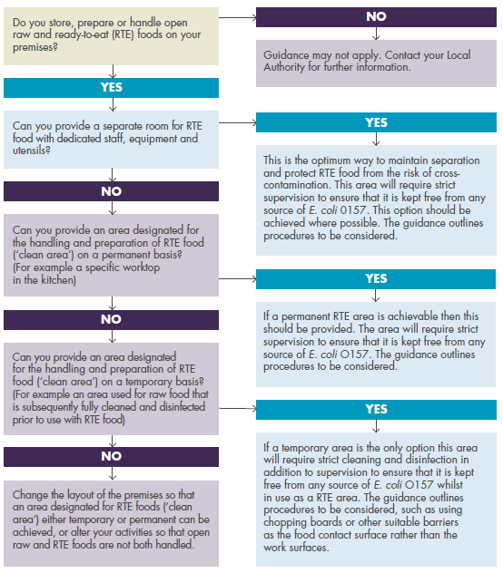
Diagram from E. coli O157 Control of Cross Contamination Guidance for Food Business Operators and Local Authorities.

2.0 Complex equipment

Vacuum packers, slicers and mincers must not be used for both raw and RTE foods unless you are able to fully dismantle and thoroughly clean all surfaces that could be contaminated. It is unlikely this will be possible during a normal working day, as it will require time being set aside to do this effectively. For vacuum packers it is unlikely to be practical for a business to regularly change their use as a competent engineer would need to undertake what is a complicated dismantling and reassembling process.

Other types of complex equipment, such as weighing scales, mixers or temperature probes may be used for both raw and RTE foods, if you put in place effective control measures, and take account of the following:-

- The complexity of the machine - for example, some mixers/food processors are more complex and more difficult to clean than simple table top varieties;
- The use of the machine - will it be used for both raw and RTE foods throughout the day, and if so, have you allowed sufficient time between use for cleaning and disinfection; and
- The required control measures, such as how cleaning and disinfection will be undertaken between raw and RTE food. This cleaning and disinfection must be undertaken using the two-stage process described in Section 3.0.

Only once these points are assessed can you determine whether dual use of these machines is suitable.

3.0 Cleaning and Disinfection

Effective cleaning and disinfection is critical in any food business.

We strongly advise the use of heat disinfection (for example, dishwasher) to clean and disinfect equipment and utensils.

Chemical disinfection may be appropriate where heat disinfection is not possible, for example a temperature probe or a work surface. To effectively disinfect areas which are used for both raw and RTE foods, a two stage cleaning process must be followed:

Stage 1: Use a suitable detergent to clean by removing any visible food residues, grease etc. This may be followed by rinsing with clean water.

Stage 2: Disinfect using a disinfectant at the correct dilution and contact time recommended by the chemical manufacturer.

Sanitisers or bactericidal detergents can be used as both a detergent and a disinfectant. If you choose to use only this chemical, you should apply it twice; first to provide a clean surface and then again to disinfect. It is often preferable to use a separate detergent to clean as sanitisers/bactericidal detergents are not always ideal for removing grease and food residues.

Disinfection will not work on visibly dirty surfaces.

Disinfectants and sanitisers used for disinfection must meet the requirements of one of the following standards: BS EN 1276 or BS EN 13697. You should contact the chemical manufacturer or supplier if this is not detailed on the label. It is essential that this chemical is used exactly according to the manufacturer’s instructions in terms of dilution and contact time.

We recommend that you use disposable single-use cloths when cleaning. If this is not possible make sure you use separate designated cleaning equipment for raw and RTE areas, for example colour coded cloths. These must also be effectively cleaned and disinfected.

4.0 Personal Hygiene

It is essential that staff follow good personal hygiene practices.

Staff should wash and dry their hands thoroughly using a recognised technique, such as the one in the E. coli guidance or in the manuals listed at the end of this factsheet.

It is very important that you and your staff wash hands before handling RTE foods, after going to the toilet, after touching raw meat/unwashed raw vegetables or touching surfaces that have come into contact with raw food.

You need to make sure that you have a separate basin that is dedicated for hand washing and is supplied with hot and cold running water, liquid soap and a hygienic means of drying hands.

Anti-bacterial hand gels should not be used instead of hand washing. They can be used afterwards as an extra level of protection.

You need to make sure that food handlers wear clean protective clothing, and if this becomes soiled it is changed before handling RTE foods. In a catering environment where staff may be preparing raw and RTE foods consecutively, such as during the cooking process, protective clothing may not need to be changed, but care should be taken to ensure clothing does not pose a risk of cross-contamination for RTE foods.

5.0 Management Control and Training

Make sure that your food safety management systems are up-to-date, are effective to control the risk of cross-contamination and are being implemented. CookSafe has a section for Cross Contamination Prevention at CookSafe - House Rules - Cross contamination prevention | Food Standards Scotland.

Staff must be supervised and instructed and/or adequately trained in the procedures and safe methods that are relevant to their job.

6.0 Further guidance

More detailed information is available within the Food Standards Scotland document E. Coli O157 Control of Cross Contamination Guidance for Food Business Operators and Local Authorities

Falkirk Council has also produced a check list which allows you to ensure that you have all necessary controls in place.

If you would like help, or need any further advice, then please contact the Food & Safety team on fs@falkirk.gov.uk. Alternatively speak to your area Environmental Health Officer/Food Safety Officer.

