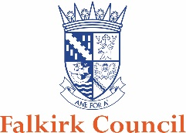

Food Safety Guidance

Genetically Modified Cooking Oil

Some catering establishments may use genetically modified (GM) cooking oil. If your business uses GM oil you are required by law to highlight the use of this product to your customers.

You must:-

Check the labelling of your cooking oil to identify whether it contains GM ingredients. For example:-

If your oil contains genetically modified ingredients, information must be permanently and visibly displayed either on the food display or immediately next to it, or on the packaging material, in a font sufficiently large for it to be easily identified and read.

Where food is not displayed or pre-packed you can highlight this information on a poster and display it in a conspicuous place or add the information to the menu. For example:-

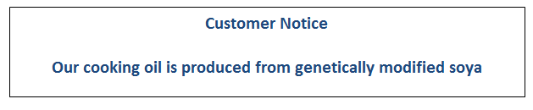

Alternatively, you should source and use oil which does not contain GM ingredients.

This is enforced in Scotland under the Genetically Modified Food (Scotland) Regulations 2004.

If you require further information or advice please contact us by emailing fs@falkirk.gov.uk

