

Transformation, Communities & Corporate Services

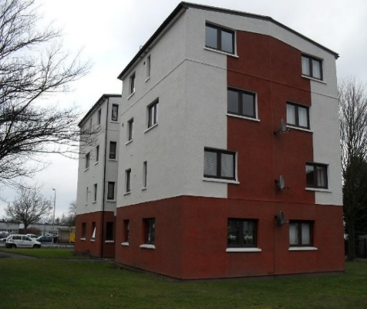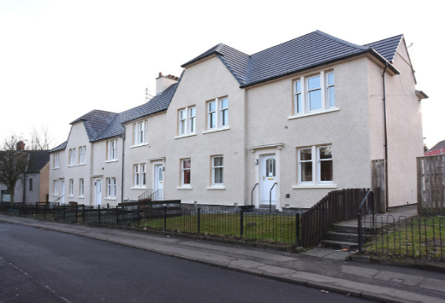

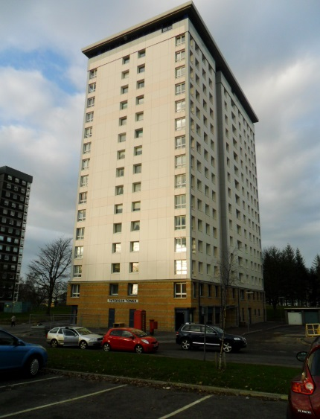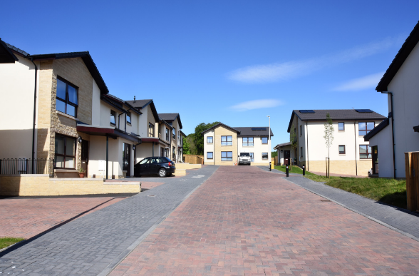

# HOUSING ASSET MANAGEMENT

# PLAN

# 2019-2024

# GLOSSARY

|  |  |
| --- | --- |
| ACRONYM | DESCRIPTION |
| AMP | Asset Management Plan |
| CAMS | Corporate Asset Management Strategy |
| CNBP | Council New Build Programme |
| DFS | Design Feasibly Studies |
| EESSH | Energy Efficiency Standard for Social Housing |
| FIR | Further Investigation Required |
| HAMP | Housing Asset Management Plan |
| HNDA | Housing Needs and Demand Assessment |
| HRA | Housing Revenue Account |
| ICT | Information and Communication Technology |
| IHMS | Integrated Housing Management System |
| LHS | Local Housing Strategy |
| OMSE | Open Market Shared Equity |
| OSA | Open Space Audit |
| PAMP | Property Asset Management Plan |
| RSL | Registered Social Landlord |
| SCS | Stock Condition Survey |
| SHIP | Strategic Housing Investment Programme |
| SHQS | Scottish Housing Quality Standard |
| SPR | Strategic Property Review |
|  |  |

# FALKIRK COUNCIL

# CORPORATE & HOUSING SERVICES

# HOUSING ASSET MANAGEMENT PLAN

**Page**

Section 1 Introduction 3

Section 2 Housing Asset Management Plan 2012-2017 8

Section 3 Housing Asset Management Plan 2019-2024 10

Section 4 Key Objectives 12

Section 5 Housing Revenue Account Assets 14

Section 6 Scottish Housing Quality Standard (SHQS) and the

Energy Efficiency Standard for Social Housing (EESSH) 26

Section 7 Information & Communication Technology 29

Section 8 Health and Safety 31

Section 9 Housing Investment Programme 33

Section 10 Review Process 35

**List of Appendices**

Appendix 1 Falkirk Council’s Asset Management Overview 37

Appendix 2 Scottish Housing Quality Standards (SHQS) Criteria 38

Appendix 3 Energy Efficiency Standard for Social Housing (EESSH) 39

Appendix 4 2019-2024 Housing Investment Programme Expenditure 40

Appendix 5 EESSH 2 Trajectory 41

**1. INTRODUCTION**

**Background**

**1.1** Falkirk Council adopted its first Corporate Asset Management Strategy ‘Better Assets, Better Services’ in 2007. This was updated and rolled forward for 2011- 2014 and was approved by Policy & Resources Committee in September 2011. The key aims of the Strategy were:-

* To create an effective Corporate Asset Management Planning process
* To modernise Corporate working practices and improve service quality
* To manage and maintain all Council assets effectively to secure best value

**1.2** The Strategy recognised the significant importance of developing an effective approach to strategic asset management as well as providing a co-ordinated framework and programme of activities to meet these objectives through actions associated with individual “classes” of assets. Since this was produced the Council has made significant progress with asset management. The focus is more outcome based with the aim of ensuring all categories of assets are clearly aligned with and support the objectives of the Council. This is recognised as critical to achieving the corporate priorities.

**1.3** In reviewing the above, consideration has been given to best practice guidelines including:-

* CIPFA – A Guide to Asset Management and Capital Planning in Local Authorities
* RICS – Public Sector Guidelines. A Guide to Best Practice
* Improvement Service – Property Asset Management in Scotland’s Councils
* Audit Scotland – Asset Management in Local Government

**1.4** It is recognised that to further the contribution of asset management in meeting the Council’s aims and objectives a structured corporate approach reflecting the clear distinction between asset classes is required.

**1.5** The Corporate Asset Management Strategy summarises the Council’s key aims and objectives for all the Council’s assets and provides the strategic framework for the six main types or classes of assets:

* Property
* Open Space
* Roads and Infrastructure
* **Housing**
* Fleet
* ICT

**1.6** The Corporate Asset Management Strategy recognises that each asset class requires a separate plan reflecting the different nature of the assets and the approaches required to effectively address its own particular issues and solutions.

**Corporate Asset Management Strategy**

**Overall Objectives**

**1.7** The strategic objectives of the current Corporate Asset Management Strategy are as follows:

* To maintain and enhance a flexible portfolio of assets best equipped to meet changing service needs and evolving methods of service delivery during a period of significant financial constraints
* To continue to critically review and challenge the need to hold specific assets in each key asset class
* To regularly review and rationalise assets to ensure they are used effectively and deliver value for money
* To utilise assets in a sustainable way to support the Council’s strategic policies, including regeneration, to contribute to a dynamic local economy and improving our environment
* To ensure assets are protected and values maintained

**1.8** Asset Management is an important element of the Council’s policies and assists delivery of its service objectives.  The Asset Management Strategy will play a vital role in helping the Council to address the pressures it will experience in the coming years to reduce expenditure and direct resources towards frontline services.

**1.9** Effective management of assets will also contribute towards the development of the area’s economy, assisting in the regeneration of the area and attracting investment.  It will assist the Council in managing its assets more sustainably and help it to meet its contribution to the national target of reducing carbon emissions by 42% by 2020 as specified in the Climate Change (Scotland) Act 2009. It is important that the assets managed by the Council help to foster cohesion in local communities, enabling services to be accessible, good quality and deliver the highest standards of service.  The Council’s aim is that Falkirk is the “place to be” in the new millennium and it is important that the Council’s assets are managed to reflect this goal.

**1.10** The strategy supports the aims of the Corporate Plan and the Strategic Community Plan and summarises the aims and objectives for assets with a view to ensuring that they are used in an efficient and effective manner. This is summarised diagrammatically in Appendix 1.

**1.11** **Corporate Asset Management Group (CAMG)**

In order to integrate asset management planning and investment decision making a close working relationship between the Council’s Corporate Asset Management and Capital Planning and Review Officer Working Groups is in place. This includes cross representation in both Groups by relevant Officers. The Group report to the Council’s Corporate Management Team, Executive and ultimately the full Council.

The group are currently focused on a number of key issues and initiatives which include:

* A Strategic Property Review (SPR), which is a key element of the *Council of the Future* programme. The SPR is part of the *Transformational Enablers* work stream which recognises the importance of managing and using properties effectively and efficiently to support changing service and customer needs. This review includes a consultation exercise which will enable a greater understanding of the community use of assets both now and in the future. The consultation will comprise of 3 focus group workshops in Denny, Bo’ness and Grangemouth in addition to an online survey. It will engage specifically with young people to obtain an insight into their views and will seek to solidify the SPR principles and will align with the Falkirk Community Trust Business Plan.
* The preparation of a Draft Property Strategy in line with SPR findings, approved asset principles and initial recommendations. A public engagement exercise will inform future strategy implementation and will be utilised to prepare a report to the Housing Executive. Implementation is ongoing in line with the key work streams, i.e.
  + Community asset use linked to Locality Planning, Falkirk Community Trust business planning and increased use of schools. Public engagement will be initiated to inform future decisions on community, leisure and sport.
  + Increased use of the ‘Learning Estate’ for educational and community purposes is to be explored and aligned to Scottish Government funding. Children’s Services are leading a response to the Scottish Government for initial projects, and this work will require alignment to SPR.
  + The establishment of a Corporate Project Team which is chaired by Children’s Services.
  + Preparation of a work programme in conjunction with the Scottish Futures Trust to inform future project recommendations in relation to PFI schools in anticipation of the end of current contracts. This programme has also been aligned to the improved use of schools.
  + Implementation of a pilot exercise to explore the adaptations of High Schools to enable increased community use. A project team has been established to assess Braes High School, and this team is currently carrying out a feasibility exercise.

* Discussions regarding space requirements in the new Council headquarters (HQ) and the workstation ratio target of 0.6 and how this can be achieved.
* The implementation of a *Smart Working - Smart Travel* campaign to encourage carbon savings and sustainable travel.
* A review of the Councils data storage arrangements. Initial discussions have been undertaken with the Councils Records Management section and the National Health Service (Forth Valley) to ascertain if there is a viable joint storage option.
* Finalising a review of service training needs to confirm whether the necessary training can be accommodated at Grangemouth Municipal Chambers and what the impact may be on the HQ requirements. The implications for Camelon Education Centre are also being considered under this review.
* The procurement exercise for the new Council HQ building which will inform ‘back-office’ requirements / implications. A review of space requirements is being finalised to allow financial and appraisal models to be tested prior to progressing the aforementioned procurement, subject to Council approval.
* Updating the Corporate Landlord / Corporate Asset Strategy.
* Consideration of other significant challenges, including: the on-going changes in the economy; legislative changes and the budget pressures which the Council continues to face
* Exploring how the Council can make certain that it can attract and retain staff to meet demands.

To ensure that the Council is ready to take on these new challenges and continue to implement transformational change, the Chartered Institute of Public Finance and Accountancy (CIPFA) working in partnership with a company called *Peopletoo* has been commissioned to carry out a review of the Councils asset, property, maintenance and facilities management functions. This review will consider:

* Delivery of our services;
* The systems and processes we use, including a workshop review of existing I.T systems and databases;
* The clarity of the relationship between Housing Services and other Council departments (e.g. Development Services, the Corporate Management Group, etc.);
* Whether the capacity and methods of operating currently utilised are sufficient to effectively deliver upon service targets; and,
* Benchmarking of the Council’s performance against other public and private sector estates.

**1.12** **Forth Valley Strategic Asset Management Plan**

A strategic review of asset management across all public sector bodies in the Forth Valley area has been taken forward with a view to identifying efficiencies arising from co-location, shared service opportunities and rationalisation. Opportunities to share the use of assets with other partners are increasingly important.

**1.13** This plan will help establish a framework for engaging strategically with partners to make more effective and efficient use of public sector assets.

**1.14** **Housing Asset Management Plan**

This plan updates the previous Housing Asset Management Plan 2012-2017 which was approved on 5th February 2013 and it will be subject to on-going review. The plan details the structure, framework, processes and aims for the strategic asset management of the Council’s housing assets. Successful progression of the actions identified in the plan will contribute to meeting the Council’s wider asset management objectives and the objectives set out in the Local Housing Strategy (LHS) 2017-2022.

**1.15** The LHS is taken forward by the Strategic Housing Group (SHG) and supports the Scottish Government’s vision that “a housing system provides an affordable home for all”. In order to progress the national vision, the LHS 2017-2022 provides housing outcomes to address housing need and demand locally.

Six priorities have been identified in the LHS which are set out below:

Priority 1 - Increasing housing supply

Priority 2 - Creating sustainable communities

Priority 3 - Access to housing

Priority 4 - Providing housing and support to vulnerable groups

Priority 5 - Tackling fuel poverty, energy efficiency and climate change

Priority 6 - Improving housing conditions

The above priorities reflect the following:

* national outcomes and strategic local plans
* statutory requirements
* housing requirements
* consultation

**2. HOUSING ASSET MANAGEMENT PLAN 2012-2017**

The approval on 5 February 2013 and implementation of the first HAMP which covered the period 2012-2017 produced a number of positive outcomes, improvements and benefits which included:

**2.1** A total of c. £118m has been spent since 2012 improving and maintaining our existing Council housing stock. This investment has resulted in an increase in the number of Council properties meeting the Scottish Housing Quality Standard (SHQS) from 82.8% in 2013 to 97.8% in 2019. In addition, the number of Council properties meeting the Energy Efficiency Standard for Social Housing in Scotland (EESSH) increased from 79.3% in 2016 to 95.6% in 2019.

**2.2** Utilising a range of initiatives to deliver new and additional affordable homes

**2.3** Expanding the scope of housing options to help meet tenants housing needs.

**2.4** The completion of 310 new homes which required a total investment of c. £40m, supported by c. £12m of grant funding.

**2.5** The purchase of 485 properties since the start of the Buy Back scheme in 2013/14 at a total cost of c. £31.9m. This investment was supported by c. £8.4m of grant funding NB: grant funding was introduced from 2015/16.

**2.6** Setting up the Empty Homes project in April 2013. Since that time, 409 properties have been brought back into use and c. £208k of debt has been recovered. The Empty Homes Project has won numerous awards.

**2.7** £9.3m of energy efficiency funding secured over the last seven financial years to improve the efficiency of the Council’s stock and provide home-owners with funding for external wall insulation and district heating.

**2.8** A programme of modernisation of all of our 13 high-rise flat blocks was completed in 2014/15, with investment of c. £2.5m per block.

**2.9** The Dawson Regeneration Initiative won the Chartered Instituted of House national award in 2012 for ‘Excellence in Regeneration’.

**2.10** The Housing Needs and Demands Assessment (HNDA) was assessed as ‘Robust and Credible’ by the Centre for Housing Market Analysis in August 2016.

**2.11** The development of a Property Evaluation Matrix in line with the 10 strategic strands set out by the Scottish Housing Regulator.

**2.12** The completion of a comprehensive assessment of the Council’s HRA land assets in 2013 and a subsequent review in 2016

**2.13** The introduction of a new re-let standard for empty properties on the 1st April 2016.

**2.14 Consultation**

The implementation of the first HAMP for the period 2012-2017 enabled the establishment of the Housing Asset Management Plan (HAMP) Group in 2012. The group consists of tenants from across the Falkirk Council area. The Group has actively engaged with Council Officers over a number of years in monitoring compliance with the Scottish Housing Quality Standard (SHQS) and the Energy Efficiency Standard for Social Housing in Scotland (EESSH). The Group discuss and influence decisions for future improvement programmes including decisions relating to the disposal and acquisition of assets. They meet every three months to discuss the progress of projects within the Housing Investment Programme (HIP) and other key performance indicators. The minutes from these meetings are shared with members of the Tenants’ and Residents Forum. The HAMP Group offers a unique and invaluable tenant and community perspective in matters relating to the management of the Council’s Housing Revenue Account (HRA) assets.

Members of the group attended the Tenant Participation Advisory Service (TPAS) conference last year to find out more about renewable energy projects. TPAS recognised the Group as an example of ‘Good Practice’. The Group have further contributed by sharing their findings and experiences with other groups nationally.

**3. HOUSING ASSET MANAGEMENT PLAN 2019-2024**

**3.1** This is the Second Housing Asset Management Plan (HAMP) to be produced by Falkirk Council. It covers the 5-year planning period from 2019-2024 and will be reviewed on an annual basis.

**3.2** Asset Management is an important element of the Council’s policies and assists delivery of its service objectives. The HAMP will play a vital role in helping the Council to address the pressures it will experience in the coming years to reduce expenditure and direct resources towards the maintenance of frontline services.

**3.3** The Scottish Housing Regulator’s inspection in 2011 and the subsequent Improvement Plan highlighted the need to establish a Housing Asset Management Plan which should be informed through consultation with key stakeholders.

**3.4** This Plan establishes a framework for housing asset management planning in Falkirk and draws together a number of initiatives and proposals.

**3.5** This plan sets out the process to be followed in making decisions relating to housing assets. Any future decisions made in relation to housing assets and their potential use will be made following consultation with service users whilst also taking into account the needs of the Council for specific types of housing.

**3.6** Co-ordination and management of the housing asset management process within Falkirk Council is the responsibility of the Property Section within Corporate and Housing Services.

**3.7** The actions proposed in this HAMP are based on the data that the Council holds on its property assets covered in this plan.

**3.8** The Council uses the information gathered from the stock condition surveys to inform capital investment planning decisions and to plan annual cyclical maintenance programmes.

**3.9** The Council has developed a 5 Year Housing Investment Programme (HIP) financial plan for the period 2019-2024 in addition to a 3-year HIP booklet for the period 2019 – 2022. These plans are based on forecast rent levels, which are subject to consultation with Council tenants under the Housing (Scotland) Act 2001. Previously the main focus of the programme has been influenced by the aim of meeting and maintaining the requirements specified in the Scottish Housing Quality Standard (SHQS) – refer to Section 6 for further details. Latterly, the energy efficiency improvements required to achieve the 2020 targets of the Energy Efficiency Standard for Social Housing in Scotland (EESSH) have been the principal focus of the programme. Further information can be found in Section 6.

The table below summarises the proposed expenditure profile for the 2019 to 2024 Housing Investment Programme:

|  |  |  |  |  |  |
| --- | --- | --- | --- | --- | --- |
| **Financial Year** | **2019/20** | **2020/21** | **2021/22** | **2022/23** | **2023/24** |
|  | **£m** | **£m** | **£m** | **£m** | **£m** |
| **Planned Investment Expenditure** | **47.700** | **72.150** | **73.550** | **48.450** | **38.150** |
| ***Resource Assumptions*** |  |  |  |  |  |
| Prudential Borrowing | 29.415 | 41.258 | 56.704 | 38.673 | 29.601 |
| CFCR | 9.680 | 9.362 | 8.983 | 7.777 | 6.549 |
| SEEPS Grant | 0.680 | 0.000 | 0.000 | 0.000 | 0.000 |
| SG Grant – New Build | 5.925 | 19.530 | 5.863 | 0.000 | 0.000 |
| SG Grant – Buy-Backs | 2.000 | 2.000 | 2.000 | 2.000 | 2.000 |
| **Total Estimated Resources** | **47.700** | **72.150** | **73.550** | **48.450** | **38.150** |

**3.10** All tenanted properties have been surveyed, although 12% of the stock has not had an internal survey carried out due to access not being obtained. In addition to this, any works carried out on properties will be updated thereby providing real time information. The external elements of properties will continue to be surveyed in order to assist with the Cyclical Maintenance Programme on a 5-year rolling basis.

**3.11**  The level of capital and revenue resources available makes it impossible for the Council to fully fund all work identified for completion within a particular time-period. Maintenance and investment plans are updated yearly, with incomplete work rolled on to the following year.

**3.12** The HAMP is consistent with the Council’s wider strategic objectives stated in the Corporate Asset Management Strategy and Single Outcome Agreements, Strategic Community Plan, Corporate Plan and Local Housing Strategy.

**3.13** In terms of the Corporate Asset Management Strategy, it is the Council’s overall objective to optimise the benefits of its assets whilst considering the environmental impact of achieving this aim.

**4. KEY OBJECTIVES**

**4.1** The Housing Asset Management Plan (HAMP) 2019-2024 is set within the context of the Scottish Governments vision as set out in the 2017-2022 Local Housing Strategy (LHS) which is: ***“a housing system provides an affordable home for all”***. The LHS recognises that there is a need to increase the supply of housing to meet current needs and to improve the condition of the existing housing stock so that it can continue to play a useful role in meeting local need. However, it also recognises that whatever is done now will have an impact on both the environment and the quality of life of individuals and communities for many years to come. In this context and given the life span of well-built housing, there is a need to ensure sustainability and safeguard the environment both now and in the future.

**4.2** This HAMP recognises that the Council’s assets are vital to the effective delivery of services within Falkirk and managing these assets requires structured and planned processes to ensure that assets:

* Are efficiently managed to meet current and future needs
* Contribute to a positive public perception of the Service
* Are regularly reviewed to ensure they are used effectively and deliver value for money
* Are regularly appraised to establish if they should be retained or whether alternative uses should be considered

**4.3** The current Corporate Asset Management Strategy (CAMS) sets out key objectives for the Council’s housing assets i.e. to:

* Continue to provide high quality affordable homes to people in housing need
* Maintain and improve our housing stock to ensure 100% of the stock meets the Scottish Housing Quality Standard by 2015
* Ensure the Council’s housing stock meets all relevant regulatory standards
* Maximise use of existing and new stock
* Maintain a balanced portfolio through new build, acquisitions, sales, remodelling, tenure diversification, demolition and redevelopment
* Continue to consult and liaise with tenants and stakeholders to ensure the housing stock and the local environment meets their needs
* Maintain and improve the environment of the Council’s neighbourhoods through regeneration and estate improvement programmes

**4.4** The HAMP aims to deliver assets that:

* Are fit for purpose
* Are sustainable
* Are in good condition
* Are accessible to all
* Are safe and secure
* Meet service needs
* Meet the needs of our communities
* Are closely aligned to the 2017-2022 LHS

**5. HOUSING REVENUE ACCOUNT ASSETS**

**5.1**  **Aim**

***“The Council aims to provide good quality, affordable and well managed homes for individuals and families in order that we can contribute to the well-being, health, education and prosperity of our communities.”***

**5.2** In order achieve this aim, the Council will:

* Manage Housing Revenue Account (HRA) assets as a corporate resource
* Ensure all HRA asset investment and disposal decisions are based on thorough option appraisal and cost benefit appraisals
* Regularly monitoring the performance of HRA assets and setting out responsibilities for securing continuous improvement
* Collect, store, and maintain HRA asset management information
* Ensure best value in the delivery of HRA asset management services
* Ensure that only HRA assets that meets the Council’s corporate objectives are retained: e.g. selling small strips of land that are considered surplus to operational requirements or disposing of non-operational property assets with high investment needs and low rental yields.
* Consider the needs of stakeholders are linked to the Local Housing Strategy
* Ensure the HRA asset portfolio is suitable for its current use and supports efficient and effective service delivery both now and in the future
* Ensure HRA assets are in an appropriate condition and maintained effectively
* Ensure all HRA assets comply with relevant legislation
* Where possible, ensure HRA property assets are accessible for people with disabilities
* Meet the demand of an increasing population, linked to the LHS and making best use of available HRA assets
* Minimise the cost and consumption of resources
* Ensure that the HRA non-operational portfolio continues to generate sufficient revenue and encourages economic development
* Manage surplus HRA assets effectively
* Procure and project manage construction projects efficiently

**5.3** Assets held on the Housing Revenue Account (HRA) are broken down into 4 distinct types and are fully explored in this section of the Plan:

* **Operational Assets** which include the Council’s core housing stock required to directly support the delivery of a housing service
* **Non-operational Assets** which provide the HRA with a revenue income stream
* **Land Assets** which have a variety of uses but are predominantly open space
* **Lock-up & Garage Assets** which are located throughout the Council’s housing estates to facilitate the storage of vehicles

**5.4 Operational Assets**

Operational assets are essential to the services delivered by Falkirk Council. Managing these assets is a structured process that seeks to ensure value for money and improved performance is delivered. It is recognised that:

* Managing the Council’s operational assets effectively is a key requirement in optimising service delivery
* The Council’s operational assets are an important visible element of the public’s perception of the Council
* The value of the Council’s operational assets and the expenditure to maintain, improve and manage the assets is significant

The following table provides details of the results of the recent valuation exercises in respect of Falkirk Councils Housing Assets:

|  |  |  |  |  |
| --- | --- | --- | --- | --- |
| **Financial Year** | **Valuation Year** | **Opening Value @ 1st April** | **Closing Value @ 31st March** | **Valuation Method** |
| **2014/15** | 5 | £54,441,000 | £54,967,000 | Discounted Cash Flow |
| **2015/16** | 1 | £54,967,000 | £337,203,000 | Beacon |
| **2016/17** | 2 | £337,203,000 | £342,168,000 | Beacon |
| **2017/18** | 3 | £342,168,000 | £349,587,000 | Beacon |
| **2018/19** | 4 | £349,587,000 | £357,163,000 | Beacon |
| **2019/20** | 5 | £357,163,000 | t.b.c |  |

The change from the Discounted Cash Flow method of property valuation to the ‘Beacon’ valuation method in the 2015/16 financial year has resulted in a much more representative valuation for our property assets with a figure of £357,163,000 at the start of the current financial year.

**5.5** Falkirk Council currently has a housing stock of 16,404 properties which were previously managed over 7 neighbourhood areas as follows:

|  |  |
| --- | --- |
| **OFFICE** | **NO OF PROPERTIES** |
| Bo’ness | 1,630 |
| Camelon | 1,579 |
| Dawson | 1,310 |
| Denny | 2,930 |
| Falkirk | 3,713 |
| Grangemouth | 3,303 |
| Stenhousemuir | 1,939 |
| **TOTAL** | **16,404** |

A recent re-classification of the seven local management areas has taken place as part of a strategic change to Housing Services, and now our housing stock has been divided into three distinct geographical ‘Hub’ management areas as follows:

|  |  |
| --- | --- |
| **HUB** | **NO OF PROPERTIES** |
| East | 4919 |
| Central | 6565 |
| West | 4920 |
| **TOTAL** | **16,404** |

The profile of the principal property types of the core housing stock can be summarised as follows:

|  |  |
| --- | --- |
| **PROPERTY TYPE** | **NO OF PROPERTIES** |
| Care Home | 74 |
| Multi-Storey | 978 |
| Flat | 4503 |
| Four-in-a-Block | 3638 |
| Detached Bungalow | 17 |
| Detached House | 4 |
| Semi-detached Bungalow | 344 |
| Semi-detached House | 2061 |
| Terraced Bungalow | 541 |
| Terraced House | 4244 |
| **TOTAL** | **16,404** |

**5.6 Housing Demand & Supply**

The Council’s Housing Needs and Demand Assessment (HNDA) which informed the 2017-22 Local Housing Strategy identifies that around 591 additional affordable homes, across all tenures, will need to be provided each year over the period from 2017 to 2022 to meet the identified shortfall in the Falkirk Council area.

There are several ways in which additional affordable homes could be provided:

• By the Council itself increasing its housing stock

• By Registered Social Landlords building either for social rent or to provide new low cost home ownership opportunities

• Through possible further phases of the National Housing Trust initiative providing properties at mid-market rents and through the Affordable Housing Policy

**5.7** It is unlikely that any one of these measures alone will be able to deliver sufficient housing to be able to meet the shortfall and so the Council’s draft Local Housing Strategy for the period 2017-22 encourages a mixture of provision to:

(a) Maximise the use of the resources available under different funding mechanisms

(b) Offer a range of housing options that include housing for rent at different levels and low cost home ownership opportunities for local people.

**5.8** The Executive approved the Strategic Housing Investment Plan (SHIP) in October 2018. This plan outlines the anticipated affordable new housing developments by both the Council and Registered Social Landlords (RSL’s) over the next five years.

**5.9** In accordance with the SHIP, it is anticipated the following Council projects will provide a further 602 homes. These developments would increase the Council’s new-build programme to c.1,000 new houses. It is anticipated that a total of £97.3m will be required over the next 5 years to enable the completion of 525 units by the end of 2024/25. A further 77 units are expected to be completed on phase 2 of the Old Denny High School site a year later in 2025/26

|  |  |  |  |
| --- | --- | --- | --- |
| **Project** | **No of Units** | **Estimated Start Date** | **Estimated Completion Date** |
| **Old Torwood School, Torwood** | 24 | April 2020 | June 2021 |
| **Bainsford Adult Day Centre** | 19 | July 2020 | September 2021 |
| **Woodend Farm, Hallglen** | 111 | July 2020 | February 2023 |
| **Main Street, Bonnybridge** | 22 | August 2020 | November 2021 |
| **Banknock South, Banknock** | 99 | September 2020 | January 2023 |
| **Oakbank, Polmont** | 24 | November 2020 | March 2022 |
| **Old Denny High School, Denny (Phase 1)** | 139 | January 2021 | September 2023 |
| **Seabegs Road, Bonnybridge** | 24 | June 2021 | August 2022 |
| **Haugh Gardens, Langlees** | 39 | July 2021 | November 2022 |
| **King Street, Stenhousemuir** | 24 | January 2023 | April 2024 |
| **Old Denny High School, Denny (Phase 2)** | 77 | November 2023 | September 2025 |
| **Unit Total =** | **602** |  |  |

**5.10 Making Better Use of the Existing Stock**

As noted in the Local Housing Strategy, the housing target for making best use of existing stock is 133***.*** The proportion of which the following initiatives will help meet the 133 target will change over time dependant on prevailing market conditions:

* Bringing empty homes back into use
* Open market resales which do not exceed Scottish Government price

ceilings for subsidised housing in the Falkirk Council area

* Mortgage to Rent acquisitions that prevent homelessness
* Open Market Shared Equity (OMSE)

**5.11** In addition, in relation to the Council’s own stock, Members recently agreed to:

* Consider providing incentives to encourage the 2,700 tenants who are currently under-occupying their homes to move to smaller accommodation
* Continue the pilot programme for a further year of extending existing properties and converting two or more smaller properties into one larger unit where it is technically feasible and cost-effective to do so,
* Consider buying back former Council properties when they become available for sale on the open market.
* Consider rationalising/remodelling the stock of flatted properties in appropriate circumstances
* Ensure new build projects reflect housing need

**5.12** **Non-Operational Assets**

Development Services (Economic Development Division) manage 243 commercial assets on behalf of Housing Services which are included under the HRA budget and which generate an annual income of c. £1m. The 243 assets are comprised of the following asset use types:

**5.13** Of the 243 commercial assets currently held on the HRA, 71 are vacant with the most significant vacancy rates being within the retail sector (63%). A break down of the current vacancy rate by asset type is detailed in the chart below:

**5.14** The primary focus for this plan is the effective use of the operational properties but it also recognises the significant impact of non-operational property in supporting economic development activities and generating income.

**5.15** Management of these properties is undertaken under the provisions of the Property Asset Management Plan (PAMP). In this context, a critical review of the Council’s non-operational property portfolio was previously undertaken. A selective disposal and re-investment strategy has been implemented aimed at improving the quality and availability of business space in order to act as a stimulus to the local economy. Progress will continue to be evaluated in line with market requirements. Over the period of this plan, further work will be carried out to assess the HRA commercial assets consistent with of the Council’s Portfolio Management Plan.

**5.16** By means of progressing the relevant activities covered by the Property Asset Management Plan, the Council will ensure that the HRA non-operational asset portfolio continues to generate appropriate revenue income and promotes economic development by ensuring non-operational assets are:

* Effectively managed
* Held for a clearly defined purpose and are regularly reviewed in terms of service delivery and performance

**5.17 Land Assets**

The Council provides a comprehensive range of soft landscape or grounds maintenance activities on a pre-planned basis in Council owned land within and around the Council’s housing estates. This includes grass cutting, shrub and flowerbed maintenance, and weed control. The HRA has a total of c. 235 hectares of land assets maintained on the Grounds Maintenance Contract which includes 7759 individual plots distributed across the Council area as detailed below:

Following the recent subdivision of the Falkirk Council Management Area into three distinct Housing ‘Hub’ areas, the aforementioned land assets are now apportioned as shown in the chart below:

**5.18** In September 2008, the Council approved a “twin-track” approach to the development of affordable housing whereby, taking account of constraints on land supply and funding availability, every effort would be made to facilitate new affordable housing provision by both the Council and RSL partners.

**5.19** During the years in which it was not economically viable for the Council to build new homes, surplus housing HRA assets were sold to RSLs for new housing development. This meant that when new Council building became a possibility once more, the supply of land available for this purpose had been significantly depleted.

**5.20** A desk-top exercise was undertaken to identify Council owned sites, including some used as public open space that might have the potential for new Council housing. 138 sites which are wholly on the HRA were identified, which encompassed approximately 250 acres. Based on a requirement to be able to deliver a minimum of 10 new units, 45 HRA sites were selected to have further investigations carried out. The 45 HRA sites were selected based on indicative site capacity and scheme deliverability. The 45 HRA sites where made up of the following current land uses:

**5.21** Design Feasibly Studies (DFS) were carried out on the 45 HRA sites to establish their suitability and deliverability as potential locations for Council new build opportunities. Each site was assessed with regard to a number of principal factors including: the planning status of the land; the current land use; the ground conditions; infrastructure constraints and estimated site capacity. The estimated capacity of the 45 sites identified the potential for in the region of 1,200 units which was based on a maximum notional capacity from a desk-top assessment. The sites were then classified as either developable, undevelopable or requiring further investigation. The current land use status of the 45 HRA sites is summarised in the following chart:

**5.22** Over the course of the first HAMP, excellent progress has been made in assessing the potential use of the 45 originally identified sites as having development potential. A full review of the HRA land assets was carried out in 2016. This review was carried out to identify potential sites that could be submitted under the Local Development Plan 2 Call for sites. 5 HRA open space sites were selected and submitted for consideration. Of the 5 land assets, 4 have been confirmed as suitable for consideration under the open space assessment criteria. This assessment will be carried out over the next year to try and assess their suitability for future Council new build projects.

**5.23** A key factor in the delivery of any potential future affordable housing by the Council will be the availability of sufficient and suitable developable land. The most cost effective way of delivering new Council homes is to build them on HRA held land. However, the detailed analysis of 45 potential new build sites highlights that the HRA does not have sufficient suitable sites to deliver a sustainable supply of land for the Council’s new build programme into the future.

**5.24** Given the restrictions of available HRA land assets, consideration requires to be given to other options to facilitate the supply of affordable housing going forward. These options, consistent with the Scottish Government’s new policy paper “Homes Fit for the 21st Century”, include:

* Transferring non-HRA land assets to the HRA
* Reclassifying some open space land (both HRA and non-HRA) to developable land
* Acquiring surplus land owned by other public bodies or private land owners
* Securing land through the Affordable Housing Policy using Section 75 agreements
* Better use of the existing housing stock

**5.25** In order to identify future sites for the Council’s new build programme, a cross service group was established to identify and discuss the use of Council assets. This group has successfully identified sites that now form part of the Council’s Strategic Housing Investment Plans. Since the first HAMP, a number of council sites have been identified as being suitable for the Council’s new build programme.

To date the following sites have been transferred to the HRA:

|  |  |  |  |  |  |
| --- | --- | --- | --- | --- | --- |
| **Area / Address** | **Committee Date** | **Decision** | **Status** | **Purchaser** | **Transfer Date** |
| **Parkhall Drive, Maddiston Primary School Site** | 24/05/2011 | Approved Transfer | Transferred | HRA | 01/07/2013 |
| **Merchiston Road, St. Mungo's School Site** | 24/05/2011 | Approved Transfer | Transferred | HRA | 01/07/2013 |
| **Tinto Drive, Grangemouth High School Site** | 24/05/2011 | Approved Transfer | Transferred | HRA | 01/07/2013 |
| **Stenhousemuir Registrar’s Office** | 12/02/2014 | Approved Transfer | Transferred | HRA | 01/05/2014 |
| **Blinkbonny Road** | 31/03/2017 | Approved Transfer | Transferred | HRA | 20/03/2017 |
| **Abbots Road, Grangemouth** | 31/03/2017 | Approved Transfer | Transferred | HRA | 20/03/2017 |
| **Torwood School Site** | 13/02/2018 | Approved Transfer | Transferred | HRA | 30/03/2018 |

**5.26** To ensure the continuation of the Council’s new build programme, the following sites are currently under consideration to be transferred to the HRA and form part of the Council’s future plans for new build programme:

* Seabegs Depot, Bonnybridge
* Old Denny High School site, Denny
* Former Social Club, Main Street, Bonnybridge
* Former Oakbank Care Home, Polmont
* Bainsford Adult Care Centre, Falkirk
* Former Social Work Office, King Street, Stenhousemuir
* Denny Town centre (Phase 2 site)

**5.27** All transferred site are discussed and agreed by the Housing Asset Management Plan Group before Service Directors approve a formal transfer. Corporate & Housing Services Asset and Investment Team maintain a register detailing all transfers.

**5.28 Lock-up & Garage Assets**

A comprehensive review of all lock-up and garage sites held on the HRA was carried out in 2010 in conjunction with Housing Operational Co-ordinators. In order to gather the data required for the appraisal process a proforma was developed and completed by Neighbourhood Officers to identify the following for each site:

* Site capacity/ units available
* Occupancy levels
* Waiting lists
* Gardens accessed from the sites
* Residents who had acquired part of the sites
* Housing Management issues
* The overall condition of the sites
* Preferred use for sites, retention/ sell for development or a change of use for allotments.

The appraisal identified:

**Lock-up sites**

* 190 lock-up sites
* Total unit capacity of 2,647

**Garage sites**

* 146 garage sites with a
* Total unit capacity of 1,333 plots

Lock-up and Garage Sites

Total Unit Capacity
- Garage Sites - 1333
- Lock-up Sites - 2647

Number of Sites
- Garage Sites - 146
- Lock-up Sites - 190

**5.29** The desktop assessment identified 54 sites as having possible development potential. The DFS assessed each of the 54 sites in relation to their suitability to provide sites for the Council’s New Council House Building Programme. The assessment of each site was based upon a range of different issues: access/traffic, environment, amenities and views, ability to integrate with the community and site conditions.

**5.30** Development Services examined each site and provided plans with indicative layouts to determine the potential footprint areas required and information relating to the placement of services within each site or in the surrounding areas. The DFS concluded of the 54 sites examined:

* 18 identified as being 1st choice - most deliverable
* 25 identified as being 2nd choice - possible development potential
* 5 identified as pre-selected
* 6 identified as being unsuitable for development and were rejected

**5.31** Taking into account the HUBs preferences and the outcome of the DFS, the 54 sites identified as having development potential and being suitable for disposal were reduced to 4 garage and 4 lock-up sites. Sites were excluded due to rear garden accesses being taken by residents backing onto the garage and lock-up sites and where there were no options for consolidation.

**5.32** A full follow up review of lock-ups and garage sites is currently underway. This may result in sites being recommend for demolition based on their current occupancy and condition. These particular sites will be considered for alternative uses or disposal.

**6. SCOTTISH HOUSING QUALITY STANDARD (SHQS) & ENERGY EFFICIENCY STANDARD FOR SOCIAL HOUSING (EESSH)**

**6.1** **Aim**

***“To manage and maintain the existing housing stock and provide new housing all in accordance with the Falkirk Council Local Housing Strategy”***

**6.2** In order to achieve this aim, the Council will:

* Continue to provide good quality affordable homes to people in housing need
* Maintain the Falkirk Council stock to a high standard
* Maximise use of existing and new stock in line with the Local Housing Strategy
* Maintain a balanced portfolio of stock and add to this through new build, acquisitions, sales and remodelling
* Diversify, demolish and redevelop properties to meet current and future housing needs
* Contribute to neighbourhood regeneration
* Encourage a Council wide approach to investment
* Ensure the stock complies with relevant regulatory requirements
* Ensure void periods are kept to a minimum and evaluate alternative approaches such as loft conversions and extensions to meet tenant need
* Meet the objectives set out in Local Housing Strategy
* Continue to hold Tenant Forums, Neighbourhood walk-abouts, consultation exercises and further develop Neighbourhood Plans

**6.3** A full Stock Condition Survey (SCS) of the Council’s c. 16,200 properties was completed in late 2010**.** The resultant data was uploaded onto the Keystone Asset Management Database. This data is kept up to date by means of regular data updates obtained from a wide variety of sources. Consequently, the database can provide accurate information to demonstrate whether each individual property currently passes or fails the Scottish Housing Quality Standard (SHQS) and EESSH – Details of the SHQS criteria ~~is~~ are set out in Appendix 2, and details of the EESSH standard are set out in Appendix 3.

**6.4** The Scottish Government introduced the Energy Efficiency Standard for Social Housing in Scotland (EESSH) in March 2014. The EESSH sets an initial standard which Social Housing properties must attain by 2020 – known as ‘EESSH 1’. This standard builds upon the requirements of the Energy Efficiency (‘Criteria C’) component of the SHQS. Social landlords were required to report upon their progress towards achieving the EESSH 1 standard from the 2015-2016 financial year onwards.

**6.5** The Keystone Asset Management Database provides detailed information relating to specific house types, building designs or geographic locations and identifies:

* Properties which currently meet the SHQS and EESSH
* Properties which fail to meet the SHQS and EESSH
* Properties where there are specific problems in achieving the SHQS and EESSH due to their construction type i.e. non-traditional types of properties
* The resources and solutions required to be explored to maintain the 2015 SHQS target and achieve the 2020 EESSH target.

**6.6** The Council currently has a stock of 16,404mainstream rented housing properties. In general terms the stock is in good condition and due to careful investment over previous years it is anticipated that the Council will meet, maintain and in some cases exceed the requirements of the Scottish Housing Quality Standard (SHQS) going forward.

**6.7** 82.7% (13,518 of 16,328) of Falkirk Council properties met the Scottish Housing Quality Standard (SHQS) on 31st March 2015. The balance of 2080 properties which did not meet the SHQS were comprised of 730 properties which were exempt and 2080 properties which were ‘in abeyance’. By 2017, the figure had increased to 93.13% (15,166 of 16,285) passing SHQS, with 6.87% being either exempt (206) or ‘in abeyance’ (913). The current figure as of 31st March 2019 is 97.73% (16,031 of 16,404) of properties passing the SHQS standard with 2.27% being either exempt (101) or ‘in abeyance’ (272).

The Councils recent performance in relation to the SHQS is summarised in the graph below:

**Scottish Housing Quality Standard (SHQS)

2014-2015
- SHQS Pass - 13518
- Exempt - 730
- In Abeyance - 2080

2016-2017
- SHQS Pass - 15166
- Exempt - 206
- In Abeyance - 913

2018-2019
- SHQS Pass - 16031
- Exempt - 101
- In Abeyance - 272**

**6.8** By 31st March 2016 79.3% of Falkirk Councils properties met the EESSH 1. By March 2017 the figure had increased to 86.2% of the housing stock. On 31st March 2019, 95.6% of properties were passing the EESSH 1 standard. In addition, the Council aims to meet and exceed the requirements of the Energy Efficiency Standard for Social Housing in Scotland **post 2020** i.e. ‘EESSH 2’.

The Councils performance in relation to the ‘EESSH 1’ from April 2015 is summarised in the following graph:

Energy Efficiency Standard for Social Housing (EESSH)

2015-2016
- EESSH Pass - 12974
- Exempt - 870
- EESSH Fail - 2525

2016-2017
- EESSH Pass - 14041
- Exempt - 553
- EESSH Fail - 1691

2017-2018
- EESSH Pass - 14863
- Exempt - 305
- EESSH Fail - 1141

2018-2019
- EESSH Pass - 15684
- Exempt - 43
- EESSH Fail - 677

**6.9** Approximately £148m will be spent over the next **five** years in order to ensure Falkirk Council meets or maintains and if possible exceeds the SHQS target and EESSH 2020 target across 100% of its stock. Details of the proposed expenditure profile for these works are detailed in Appendix 4.

**7. INFORMATION & COMMUNICATION TECHNOLOGY (ICT)**

**7.1** Corporate and Housing Services uses a significant range of IT assets including;

* Communication Lines and network equipment (including Cabling, Switches, hubs etc.)
* Servers (Applications)
* Servers (Enterprise Applications – Servers e.g. Web, email, content management, Firewall etc.)
* Storage Server
* PCs, Laptops, handheld devices, printers, scanners etc.
* Software Applications and systems
* Software Licences, Contracts and Certificates – Enterprise (Microsoft

Enterprise Agreement, Security, Domain Names, Security Certificates etc)

* Software Licences – Application e.g. MS Office, Academy etc
* Shared Network devices e.g. Network Printers etc
* Data and Information

This will be further expanded over the next 5 years to include new technologies such as

* Cloud Computing
* Robotic Process Automation / Artificial Intelligence
* Internet of Things

**7.2** Our current housing asset management database was introduced in 2012 and was populated with information gathered from the 2010 Stock Condition Survey. This information is continually updated through a 5 year rolling programme of stock condition and cyclical maintenance surveys.

**7.3** The service has identified that a new fully Integrated Housing Management System including an Asset Management solution is required to ensure that the service is fully modern, digital and adheres to the Council’s corporate digital strategy. It will also ensure that the Council will be able to forward plan for continuous improvement to meet the demands of legislation and changes in housing needs. It is expected that the new Housing Management System will be fully implemented by June 2022.

**7.4** A fully integrated Asset Management Solution will also enable the Council to more efficiently manage its assets and measure performance against the SHQS and EESSH standards as well as highlighting potential energy efficiency improvements and any asbestos containing materials present in the stock. It will also provide additional analysis and reporting functionality to plan programmes of work and cost future expenditure.The completion of the current three year Housing Investment Programme for 2019-2022 will be followed by future plans over a 5 year period which will also allow 30 year financial plans to be prepared to demonstrate the overall sustainability of the Council’s operational assets. This will provide the Council with invaluable information allowing us to set and agree HRA budgets for future spending to benefit our tenants.

**7.5** A fully integrated Asset Management Solution will also assist when collating and providing asset information for the Scottish Government and for any other audit purposes, corporate returns and when forecasting and programming future works.

**7.6** The diagram below gives an overview of the existing Asset Management framework. However, as an Asset Management Solution will be integrated as part of the new Housing Management System, this Framework will be subject to change. The new system will further enable Corporate and Housing Services to deliver an effective and efficient asset management framework.

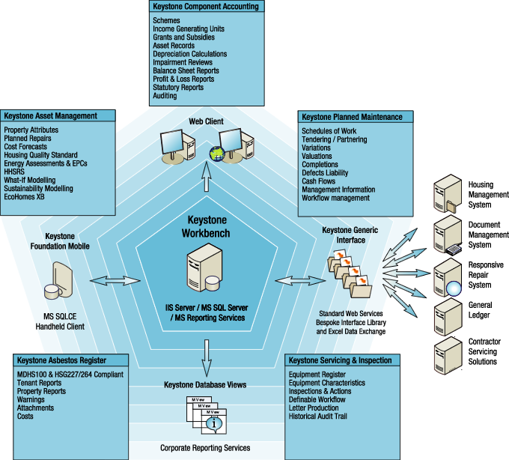

**7.7 Goals**

* Ensuring the effective and efficient identification, management and operation of ICT Assets
* Effective planning, procurement and deployment of ICT Assets solutions
* Ensuring that assets are suitable, operational, accessible and maintained to required standards
* Ensuring that new assets are sustainable and affordable for the whole life of the asset
* Complying with legislative and operational requirements during the effective retiral and disposal of ICT assets

**8. HEALTH & SAFETY**

**8.1** Falkirk Council considers the management of health, safety & care to be a fundamental part of every activity it undertakes and every service it delivers to the community. The Council will take all reasonable steps to ensure the health, safety & care of all employees at work and others who may be affected by our activities i.e. clients, or members of the public who are either directly or indirectly affected by the Council’s work activities.

**8.2** Corporate and Housing Services will endeavour to comply with all Health & Safety Legislation at all times and deliver a high standard of Health & Safety performance. To achieve this, Corporate and Housing Services will:

* Adopt a planned and systematic approach to the implementation of the Strategic Plan for Health, Safety & Care
* Secure the commitment and participation of all Management Teams, employees and Trade Unions to create and maintain a positive Health & Safety culture
* Review safe systems of working practices and apply methods of effective communication
* Meet our responsibilities to employees, citizens and the environment in a manner which recognises that legal requirements are the very minimum standards and introduce pro-active measures and initiatives to continually improve on health, safety & care in accordance with Health & Safety Executive and Scottish Executive campaigns and initiatives
* Establish a cascade approach to the communication of Health & Safety matters and ensure that Health & Safety is a standing agenda item on management and team meeting agendas
* Train employees to work safely and competently
* Adopt a Risk Management by Risk Assessment process for all relevant activities to identify, assess and eliminate risks, so far as is reasonably practicable
* Set targets for health, safety & care performance
* Monitor performance through audit and review and benchmark the Council’s performance against targets and similar organisations

**8.3** Falkirk Council will seek to develop a positive attitude to health, safety & care amongst all employees and ensure that health, safety & care is an integral part of the overall management culture.

**8.4** The Council’s Health, Safety & Care Policy applies to all Corporate and Housing Services, divisions and management teams and to all employees, local members, volunteers who assist in the work of the Council and any other persons affected by the Council’s activities.

**8.5** In line with this policy, Corporate and Housing Services has addressed several factors to be considered in ensuring that our tenants are also not at risk and in addition to an effective repairs service, we also carry our checks on:

* Asbestos
* Legionella
* Fire safety
* Gas
* Lifts
* Electrical Periodic inspections

**8.6 Asbestos Management**

The Council and Housing Services have implemented robust procedures and mechanisms to ensure the safety of our residents, tradespersons and other visitors in relation to our domestic properties, including the following:

* The review and update of the Corporate Asbestos Policy in 2018 to fully reflect the requirements of all relevant current legislation and best practice guidance;
* An accelerated survey exercise in 2018/19 which targeted over 6000 tenanted properties where there was limited or no data available in respect of the presence of Asbestos Containing Materials (ACM’s). Access was gained to over 90% of the properties and an Asbestos Management Survey - with samples where required - was obtained which enabled the creation of a detailed data entry in the asbestos register
* The annual inspection of the communal non-domestic areas within 708 of our domestic blocks in order to meet our duty to manage ACM’s under Regulation 4 of the Control of Asbestos Regulations 2012; and,
* The provision of Independent Asbestos Training Providers (IATP) approved annual asbestos training to over 350 operatives and supervisory staff

As a result, the Asbestos Register maintained by Housing Services now contains asbestos data in respect of 95% of its domestic properties and has the data from a full Asbestos Management Survey - with samples where appropriate – for over 90% of its domestic stock.

**8.7 Actions Following the Incident at Grenfell Tower**

Following the tragic incident at Grenfell Tower in June 2017, the Council carried out a detailed technical assessment of all of the Councils high-rise properties in order to allay concerns about fire safety in these blocks. Based on the information available, the cladding types and construction methods used on Grenfell Tower are fundamentally different from those used on the Councils high rise blocks. All of our cladding works were designed and installed to comply fully with the relevant Scottish Building Standards Regulations and have been subject to building warrant approval. In addition, it has been established that the materials and construction methods used in our high rise properties are inherently a very low fire risk.

The Council has put robust mechanisms and procedures in place to ensure the safety of our residents within our high rise blocks. These include the following:

* The installation of sprinkler systems within the bin store areas;
* Updating and improving the emergency signage in communal areas;
* The provision of additional fire safety training for relevant staff members;
* Regular inspections of communal areas by our Housing Officers and Caretakers;
* Regular inspections of equipment such as fire extinguishers, fire alarms & smoke alarms;
* Regular inspections of key fire safety building elements including dry risers, fire doors and emergency lighting; and
* Annual fire safety inspections of the high-rise blocks.

The Council will continue to liaise with Scottish Government and the Scottish Fire and Rescue Service on an ongoing basis. In addition, the Council will continue to review and update any of our processes and procedures as appropriate as and when more official information and guidance becomes available.

**9. HOUSING INVESTMENT PROGRAMME**

**9.1** The Housing Asset Management Plan sets out the aims and objectives for the Council’s assets to ensure that they are used in an effective and efficient manner. This section deals with the links between asset management planning and the HRA Investment Programme. Whilst Falkirk Council has a fully implemented Corporate AMP, the Housing Asset Management Plan will link directly to the aims and objectives of the Corporate Plan and the Local Housing Strategy.

**9.2** In 2004-2005 the Prudential Code replaced the longstanding Section 94 system of capital control. The basic principle of the new system is that Councils will be free to invest so long as their capital spending plans are affordable, prudent and sustainable. This principle continues to be followed in preparing this programme.

**9.3** The introduction of the Energy Efficiency Standard for Social Housing in Scotland (EESSH) in March 2014 and the continued need to meet the Scottish Housing Quality Standard (SHQS) is influencing and will continue to influence the Council’s investment priorities, the impact of which will be monitored throughout this programme. Achieving and maintaining ~~this~~ these Standards, through HRA investment, supported by prudential borrowing, will be a key element in the Council’s strategy of stock retention detailed in the Local Housing Strategy (LHS).

**9.4** Work continues in relation to validating, updating and refining stock condition information obtained via the full Council House Condition Survey. This data is available via our Keystone asset management database. This data will be used to help inform future investment decisions and identify priority projects in all of the stages of this programme. Consequently, in certain instances projects have not been included in Years 2 and 3 in order to allow the programming of projects in light of updated stock information becoming available.

**9.5** In order to ensure that all homes meet the SHQS and EESSH standard, the Council has allocated £147m over the next 5 financial years. A total of £47.7m has been provided for 2019/2020 for new investment, together with planned investment of £72.15m in 2020/2021, £73.55m in 2021/2022, £48.45m in 2022/2023 and £38.15m in 2023/2024.

**9.6** The above spend has been divided into the programme and is detailed in Appendix 4.

**9.7** The production of the Housing Investment Plan involved:

* Quantifying available resources
* Using the stock condition information and Housing Asset Management Database to inform investment decisions
* Targeting investment towards ensuring the Council’s core housing stock meets the SHQS and EESSH standards.
* Prioritising investment for the remaining resources

**9.8**  **Future Investment Decisions**

The Council’s housing asset management database will be maintained and developed to:

* Prioritise investment to maintain the SHQS and meet the EESSH standard by 2020
* Plan for the impact of the proposed EESSH 2Standard from 2020 onwards (refer to Appendix 5 for details).
* Establish a 5 year Housing Investment Plan
* Allow better investment decisions
* Allow meaningful dialogue to take place with stakeholders on investment decisions and budget setting
* Allow early dialogue to take place with owner occupiers in terms of their involvement in communal improvement projects
* Ensure resources are targeted where they are most needed
* Allow the development of a 30 year business plan to establish the overall sustainability of the Council’s operational HRA assets
* Allow meaningful scenario planning to be carried out on the impact of rent changes

**10. REVIEW PROCESS**

**10.1** The HAMP will be linked to the LHS and the HIP to provide an overall framework for securing Best Value in the use of resources and assets.

**10.2** To ensure that this is translated into ongoing delivery at an operational level, elected members and stakeholders will be fully involved in any decisions relating to HRA assets and the following action will be taken:

* The Housing Investment Plan and Asset Management Plan will be reviewed annually
* Quarterly capital monitoring reports will be presented to the Policy and Resources Committee outlining progress on implementation of the capital programme
* Disposal of assets will be taken by the appropriate Committee

**10.3 Continuous Review**

We will ensure the long-term sustainability of our assets meet the principles of Best Value by carrying out regular reviews to make informed decisions about the future use of assets. These reviews will be done to inform decisions about our stock retention or disposal strategies. Decisions will be informed by a formal option appraisal process which takes cognises of:

1. On-going maintenance costs
2. Maintenance costs over the expected life of the asset
3. Level of demand
4. High turnover
5. Poor environmental quality
6. Concentrations of social exclusion

A continuous cycle of review will be implemented to manage and identify risks:

**IDENTIFY RISK**

**ASSESS RISK**

**MANAGE & CONTROL RISK**

**REVIEW & REPORT RISK**

**10.4** **Asset Realisation**

Notwithstanding the financial pressures faced by the Council presently, disposal of non-operational HRA assets or HRA land assets to generate capital receipts may result in significant losses of rental income or the future availability of land or property for other strategic uses. It is inevitable that the disposals of assets will become progressively more difficult as the best assets are sold.

Any decisions to dispose of HRA assets will be informed by carrying out a full option appraisal exercise to establish if the disposal of an asset represents best value to the Council.

**10.5**  **Decision Process**

Any proposals to dispose of HRA assets will be considered by the Council’s Corporate Asset Management Group and the Housing Asset Management Group before being reported to Executive.

Consultation with local members is carried out before preparing a report for Executive. Where appropriate, communities will also be consulted on proposed asset disposals which have a significant impact on the community.

A full register of all asset disposals and acquisitions is managed and maintained by the Asset & Investment Team.

**Appendix 1**

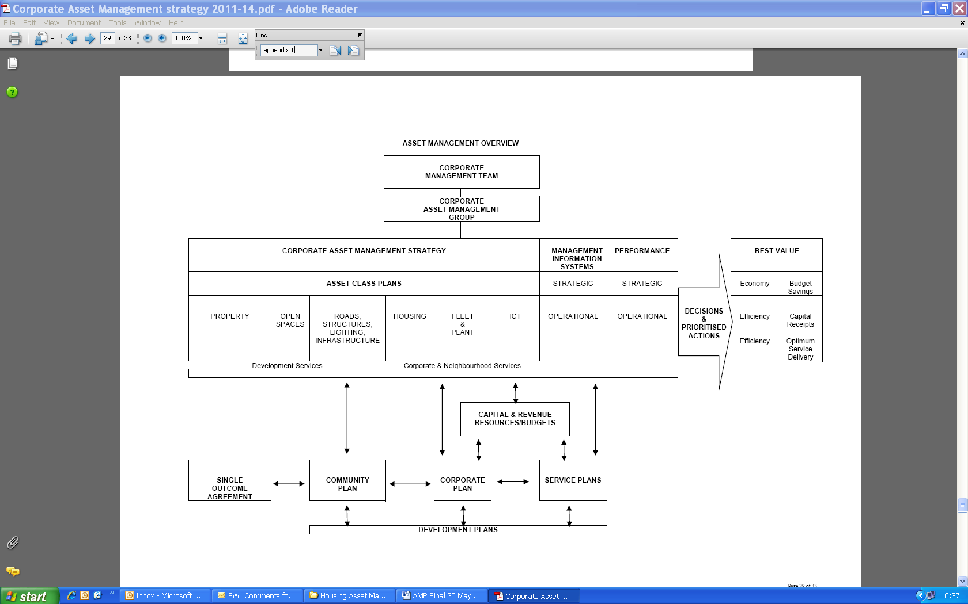

**Appendix 2**

**SCOTTISH HOUSING QUALITY STANDARD (SHQS)**

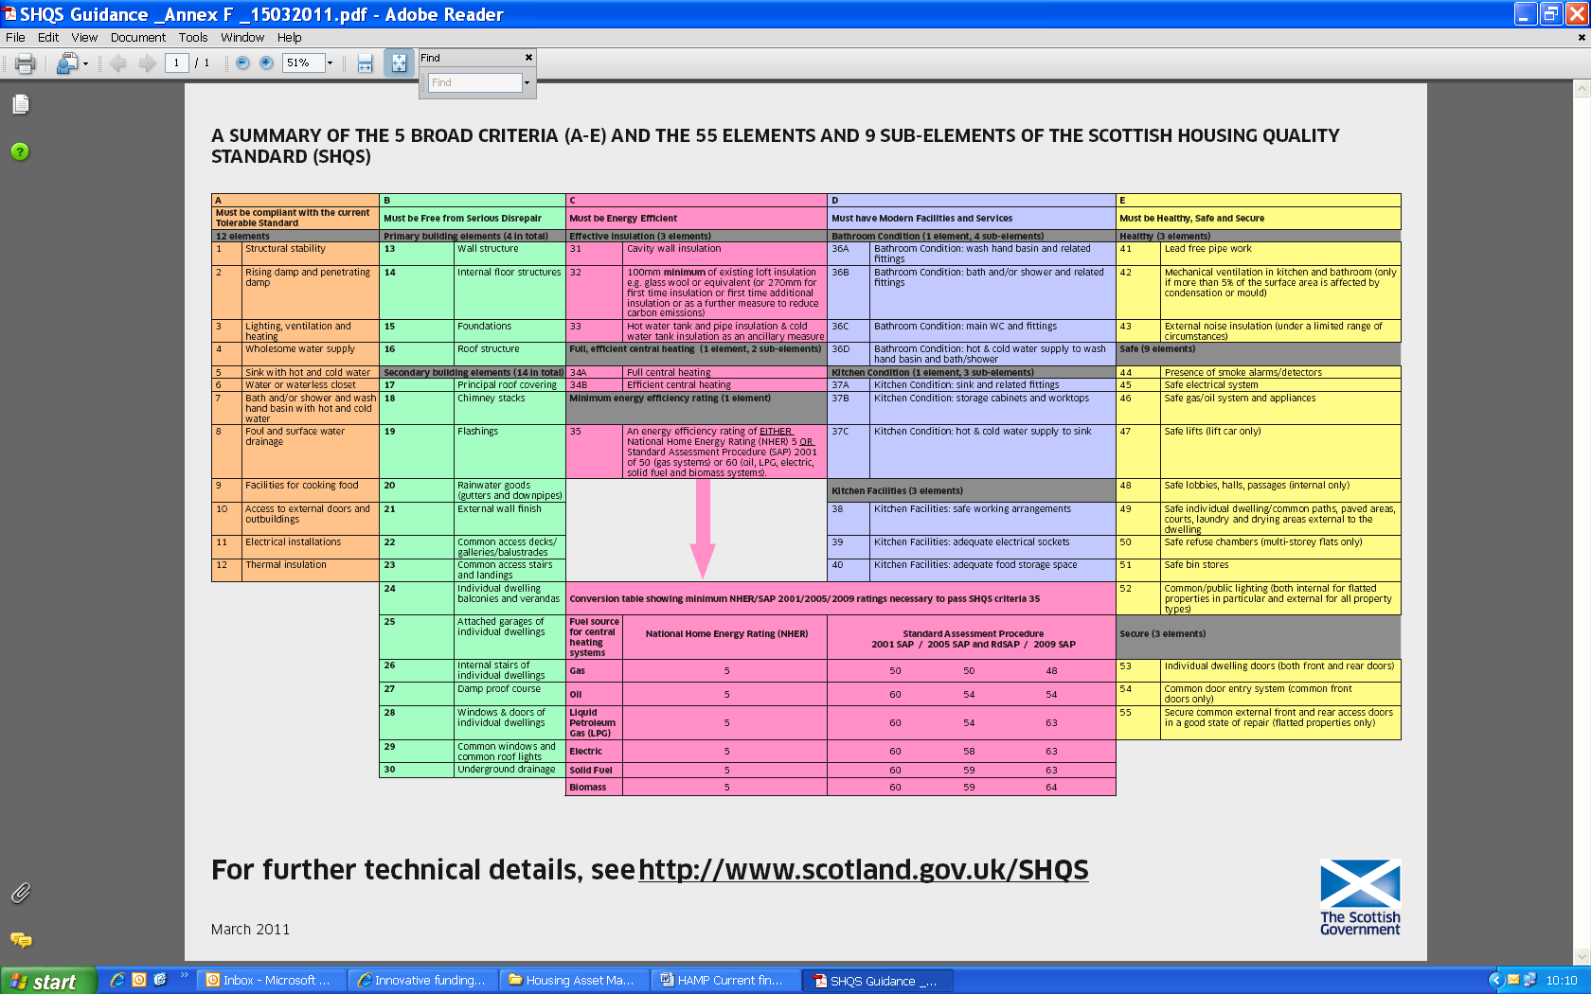

**Appendix 3**

**THE ENERGY EFFICIENCY STANDARD for SOCIAL HOUSING (EESSH)**

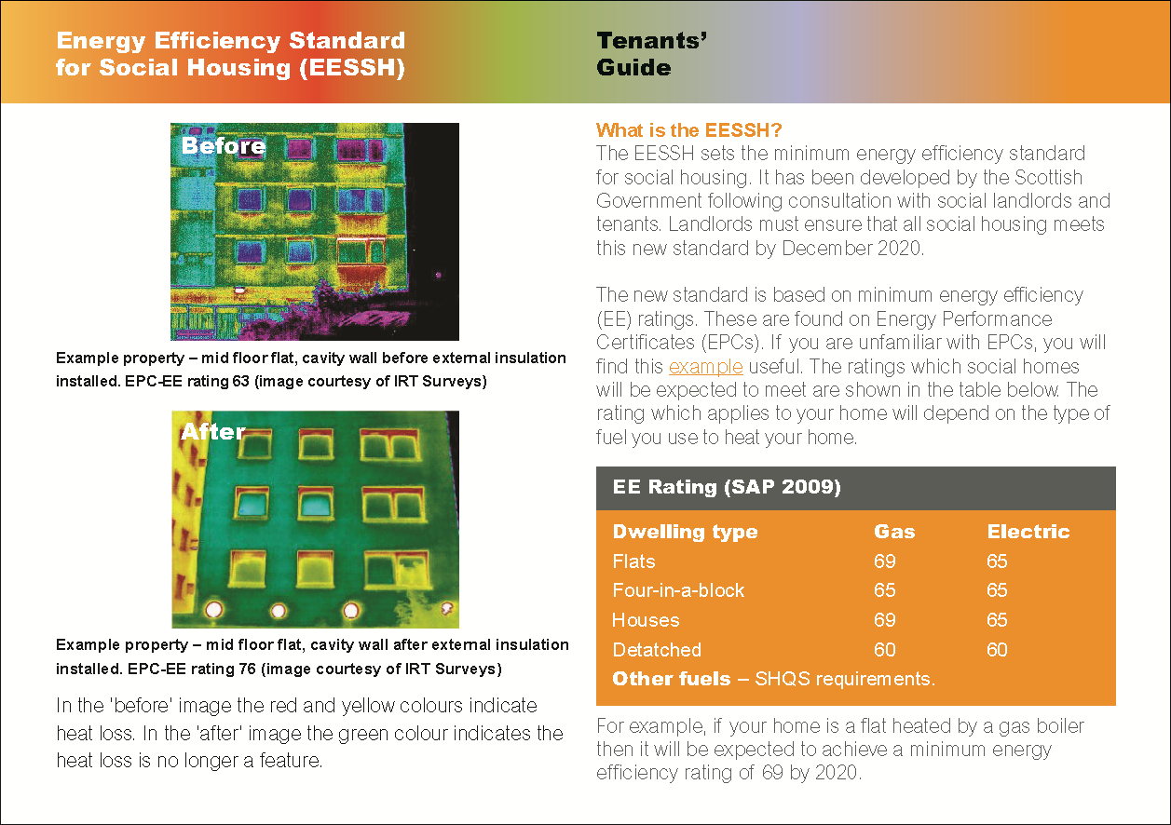

**Further guidance available at:** [**https://www.gov.scot/publications/energy-efficiency-standard-social-housing-eessh-tenants-guide/**](https://www.gov.scot/publications/energy-efficiency-standard-social-housing-eessh-tenants-guide/)

**Appendix 4**

**2019/20 to 2023/24 HOUSING INVETSMENT**

**PROPOSED EXPENDITURE PROFILE**

|  |  |  |  |  |  |  |
| --- | --- | --- | --- | --- | --- | --- |
| **HOUSING IMPROVEMENT WORKS** |  | **2019/20** | **2020/21** | **2021/22** | **2022/23** | **2023/24** |
|  |  | **Year 1 of 5** | **Year 2 of 5** | **Year 3 of 5** | **Year 4 of 5** | **Year 5 of 5** |
| **Elemental Maintenance & Improvements** |  | **£m** | **£m** | **£m** | **£m** | **£m** |
| **External Fabric Improvements** |  | 8.000 | 8.00 | 6.000 | 6.000 | 5.000 |
| **Window and Door Replacement** |  | 0.000 | 12.000 | 12.000 | 12.000 | 12.000 |
| **Kitchen/Bathroom Renewal** |  | 3.500 | 3.500 | 3.500 | 3.500 | 3.500 |
| **Electrical Works** |  | 2.000 | 2.000 | 2.000 | 2.000 | 2.000 |
|  | **Sub-Total** | **13.500** | **25.500** | **23.500** | **23.500** | **22.500** |
| **Energy Efficiency Works** |  | **£m** | **£m** | **£m** | **£m** | **£m** |
| **Replacement Heating** |  | 1.400 | 2.100 | 2.800 | 2.000 | 2.000 |
| **Combined Heat & Power Extension** |  | 3.600 | 0.000 | 0.000 | 0.000 | 0.000 |
| **Heating Upgrade (High Rise)** |  | 2.700 | 0.000 | 0.000 | 0.000 | 0.000 |
|  | **Sub-Total** | **7.700** | **2.100** | **2.800** | **2.000** | **2.000** |
| **Estate Improvements** |  | **£m** | **£m** | **£m** | **£m** | **£m** |
| **Estate Improvement Work** |  | 3.500 | 3.500 | 2.200 | 2.200 | 2.200 |
|  | **Sub-Total** | **3.500** | **3.500** | **2.200** | **2.200** | **2.200** |
| **Priority Areas** |  | **£m** | **£m** | **£m** | **£m** | **£m** |
| **Other Priority Areas** |  | 1.850 | 2.000 | 2.000 | 1.500 | 1.500 |
|  | **Sub-Total** | **1.850** | **2.000** | **2.000** | **1.500** | **1.500** |
| **Health & Safety** |  | 3.350 | 3.850 | 0.350 | 0.350 | 0.350 |
|  | **Sub-Total** | **3.350** | **3.850** | **0.350** | **0.350** | **0.350** |
| **NON-IMPROVEMENT EXPENDITURE** |  | **2019/20** | **2020/21** | **2021/22** | **2022/23** | **2023/24** |
|  |  | **Year 1 of 5** | **Year 2 of 5** | **Year 3 of 5** | **Year 4 of 5** | **Year 5 of 5** |
| **New Build Housing** |  | **£m** | **£m** | **£m** | **£m** | **£m** |
| **Construction Works** |  | 10.500 | 28.500 | 36.000 | 12.200 | 2.900 |
|  | **Sub-Total** | **10.500** | **28.500** | **36.000** | **12.200** | **2.900** |
| **Property Buy-Backs** |  | 6.000 | 6.000 | 6.000 | 6.000 | 6.000 |
| **Other Works (LHS Initiatives)** |  | 1.300 | 0.700 | 0.700 | 0.700 | 0.700 |
|  | **Sub-Total** | **7.300** | **6.700** | **6.700** | **6.700** | **6.700** |
| **Total Expenditure** | **Sub-Total** | **47.700** | **72.150** | **73.550** | **48.450** | **38.150** |
| **Resources** |  | **£m** | **£m** | **£m** | **£m** | **£m** |
| **Prudential Borrowing** |  | 29.415 | 41.258 | 56.704 | 38.673 | 29.601 |
| CFCR |  | 9.680 | 9.362 | 8.983 | 7.777 | 6.549 |
| SEEPS Grant |  | 0.680 | 0.000 | 0.000 | 0.000 | 0.000 |
| SG Grant – New Build |  | 5.925 | 19.530 | 5.863 | 0.000 | 0.000 |
| SG Grant – Buy-Backs |  | 2.000 | 2.000 | 2.000 | 2.000 | 2.000 |
|  |  | **Year 1 of 5** | **Year 2 of 5** | **Year 3 of 5** | **Year 4 of 5** | **Year 5 of 5** |
| **Total Income** |  | **47.700** | **72.150** | **73.550** | **48.450** | **38.150** |

**Appendix 5**

EESSH 2 Trajectory

2025
-EESSH Review
- Air Quality and Environmental Impact Elements
- No New Lets Below EPC Band D

2032
- All Stock EPC Band B, or treated as such, or as close as possible within cost/technical/consent limits

2040
-Vision for removal of poor energy efficiency as a driver of fuel poverty and for homes to be Zero Carbon



Asset & Investment Team

Suite 4, the Forum,

Callendar Business Park

FK1 1XR